CSC3150 Operating System CP. 118010141 李璟瑜。和3050类似，考察概念，不考细节。注意对名词的解释.

3050考了什么：软硬件怎么合作；名词解释题TLE；定律解释；pipeline计算；

Cha1: Introduction.

What is OS? **Program** intermediary between user & hardware. Goal: easier user problem convenience efficient hardware.

Computer system = hardware (CPU,memory,I/O) + OS + app + user

mainframe and minicomputer for user: ease of use no resource utilization

OS=resource allocator+control program(error,bad use,segmentation fault)

**Kernel**: running all the time. Others=sp+ap.

**Bootstrap program**:开关机firmware初始化加载kernel

ROM: 只读存储器 EPROM可擦可编程只读存储器

**System organization**: One or more CPUs, device controllers connect through **common bus** providing access to shared memory

Concurrent execution of CPUs and devices competing for memory cycles

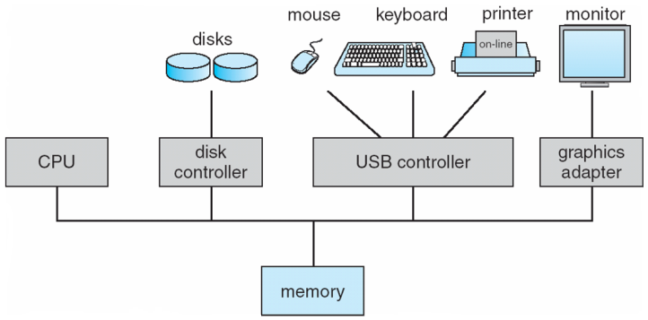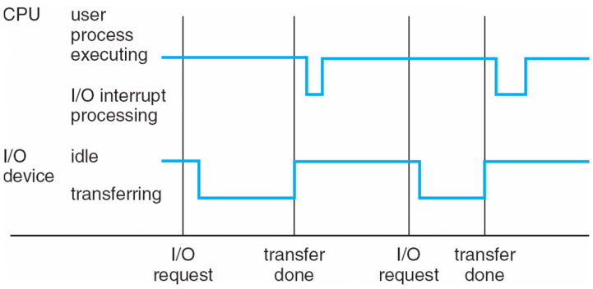

Concurrently: 看上去多个，但任意时间点只有一个请求被处理（I/O+CPU）。Simultaneously：一个时间点多个程序运行

Device controller：一对一，local buffer——CPU和内存的数据交换。I/O：device to local buffer

**Device controller informs CPU that it has finished its operation by causing an interrupt**

Interrupt transfers control to the **interrupt service routine** generally, through the **interrupt****vector**, which contains the addresses of all the service routine**（IRQ1-32）**

Interrupt architecture must save the address of **the interrupted instruction OS=interrupt driven**

* A **trap** or **exception** is a software-generated interrupt caused either by an **error** or a user request Division by zero, request for operating system service Other process problems include infinite loop, processes modifying each other or the operating system

The operating system preserves the state of the CPU by storing **registers and the program counter**

决定interrupt类型：**Polling vectored interrupt system**

**Separate segments of code** determine what action should be taken for each type of interrupt

Synchronous I/O: After I/O starts, control returns to user program only **upon I/O completion**

* + Wait instruction idles the CPU until the next interrupt
  + Wait loop (contention for memory access)
  + At most **one** I/O request is outstanding at a time, no simultaneous I/O processing

Asynchronous I/O: After I/O starts, control returns to user program without waiting for I/O completion

* + **System call – request to the OS to allow user to wait for I/O completion**
  + **Device-status table contains entry for each I/O device indicating its type, address, and state**
  + OS indexes into I/O device table to determine device status and to modify table entry to include interrupt

**Storage-Device Hierarchy: Registers-Cache-main memory-ssd-magnetic disk-optical disk-magnetic tapes 根据speed & cost & volatility排序**

几种存储类型与结构

Main memory – **only** large storage media that the CPU can access directly **Random** **access** Typically **volatile 不稳定，数据会消失**

Secondary storage – extension of main memory that provides large **nonvolatile** storage capacity

Magnetic disks – rigid metal or glass platters covered with magnetic recording material

* + Disk surface is logically divided into **tracks**, which are subdivided into **sectors**
  + The **disk controller** determines the logical interaction between the device and the computer

**Solid-state disks** – **faster** than magnetic disks, nonvolatile 多种科技，变得流行。固态硬盘good

**Caching** – copying information into faster storage system; main memory can be viewed as a cache for secondary storage

* Information in use copied from slower to faster storage temporarily
* Faster storage (cache**) checked first** to determine if information is there
  + If it is, information used directly from the cache
  + If not, data copied to cache and used there
* Cache smaller than storage being cached (cache management, size, replacement)

**Device Driver** for each device controller to manage I/O Provides uniform interface between controller and kernel

**Direct Memory Access Structure**

* Used for high-speed I/O devices able to transmit information at close to memory speeds
* Device controller transfers blocks of data from **buffer storage** directly **to main memory** without CPU intervention 设备缓存直接到内存，没有CPU干扰
* Only one interrupt is generated per block, rather than the one interrupt per byte

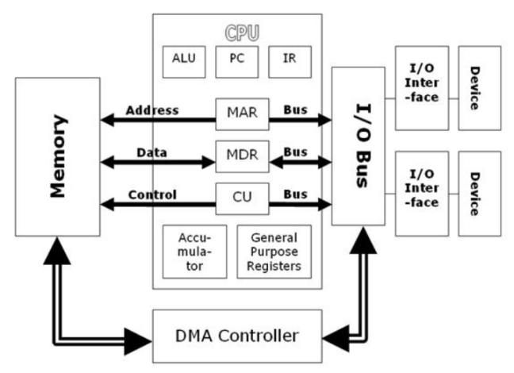 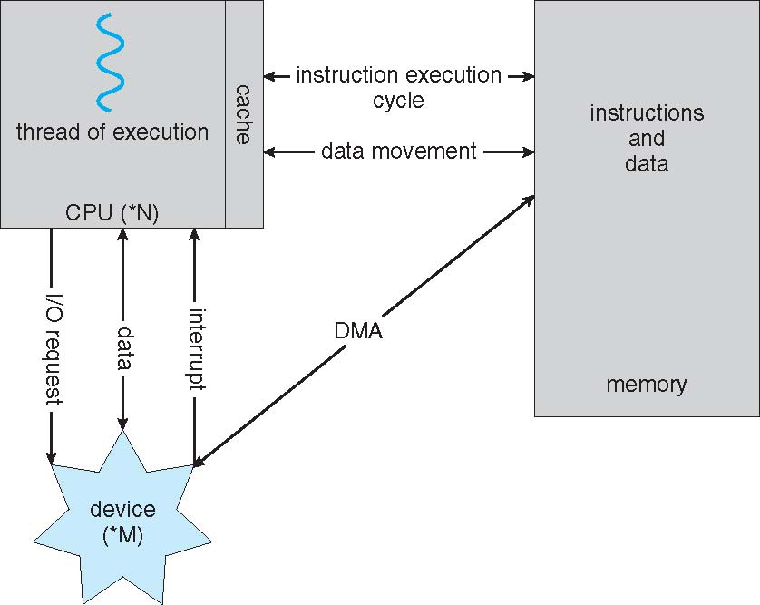

Most systems use a single general-purpose processor (PDAs through mainframes)

Most systems have special-purpose processors as well

**Multiprocessors** systems / **parallel systems / tightly-coupled systems (Symmetric / asymmetric)**

优点：**Increased throughput Economy of scale Increased reliability – graceful degradation** or **fault tolerance**

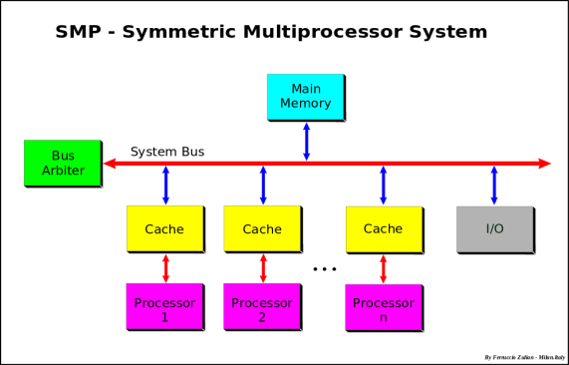 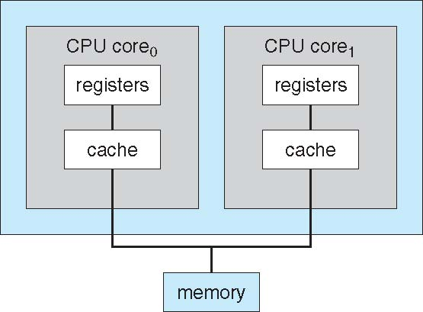

对称：每个处理器对应一个cache

Dual-core：UMA + NUMA. Multicore Systems containing all chips vs. **blade servers**Chassis containing multiple separate systems

**Clustered Systems 多系统共同运作 sharing storage via a storage-area network (SAN)**

Provides a **high-availability** service which survives failures

* + - **Asymmetric clustering** has one machine in hot-standby mode
    - **Symmetric clustering** has multiple nodes running applications, monitoring each other

**high-performance computing (HPC)： Applications must be written to use parallelization 并行计算**

Some have **distributed lock manager** (**DLM**) to avoid conflicting operations

1.08.pdf

**Multiprogramming** needed for efficiency 规划jobs. OS-job1-job2-…-jobn (内存排布)

* + Single user cannot keep CPU and I/O devices busy at all times
  + Multiprogramming organizes jobs (code and data) so CPU always has one to execute
  + A subset of total jobs in system is kept in memory
  + One job selected and run via **job scheduling**
  + When it has to wait (for I/O for example), OS switches to another job

**Timesharing** (**multitasking**)is logical extension in which CPU switches jobs so frequently that users can interact with each job while it is running, creating **interactive** computing 调换jobs，互动体验

* + **Response time** should be < 1 second
  + Each user has at least one program executing in memory 🢡**process**
  + If several jobs ready to run at the same time 🢡 **CPU scheduling**
  + If processes don’t fit in memory, **swapping** moves them in and out to run
  + **Virtual memory** allows execution of processes not completely in memory

双重模式设计：user + Kernel

* **Dual-mode** operation allows OS to protect itself and other system components
  + **User mode** and **kernel mode**
  + **Mode bit** provided by hardware
    - Provides ability to distinguish when system is running **user code** or **kernel code**
    - Some instructions designated as **privileged**, only executable in kernel mode

**System call changes mode to kernel,** return from call resets it to use

CPU支持多核操作。VMM for guest VMs

**Transition from User to Kernel Mode**

* Timer to prevent infinite loop / process hogging resources
  + Set interrupt after specific period
  + Operating system decrements counter
  + When counter zero generate an interrupt
  + Set up before scheduling process to regain control or terminate program that exceeds allotted time

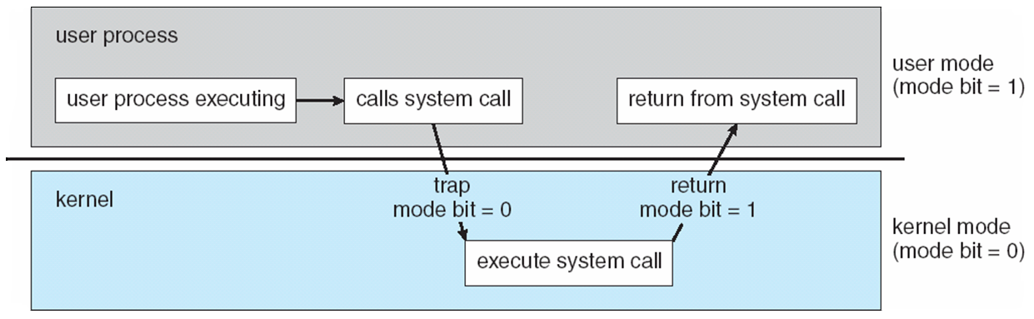

**Process Management**

A process is a program in **execution**. It is a unit of work within the system. Program is a ***passive entity***, process is an ***active entity***.

需要的资源：CPU, memory, I/O, files Initialization data

Process termination requires reclaim of any reusable resources

单线程：一个Program counter，指着下一条指令的位置 顺序执行，知道结束 多线程：每个线程一个PC

Concurrency by multiplexing the CPUs among the processes / threads。

进程管理任务：

* Creating and deleting both user and system processes
* Suspending and resuming processes
* Providing mechanisms for process synchronization
* Providing mechanisms for process communication
* Providing mechanisms for deadlock handling

**Memory Management**

所有在内存中的数据，指令。

* Memory management determines what is in memory when
  + Optimizing CPU utilization and computer response to users

内存管理任务：

* + Keeping track of which parts of memory are currently being used and by whom
  + Deciding which processes (or parts thereof) and data to move into and out of memory
  + Allocating and deallocating memory space as needed

**Storage Management**

* OS provides uniform, logical view of information storage 存储的性能多样性
  + **Abstracts** physical properties to logical storage unit - **file**
  + Each medium is controlled by device (i.e., disk drive, tape drive)
    - Varying properties include access speed, capacity, data-transfer rate, access method (**sequential or random**)
* File-System management
  + Files usually organized into directories
  + Access control on most systems to determine who can access what

文件管理任务：

* + - Creating and deleting files and directories
    - Primitives to manipulate files and dirs
    - Mapping files onto secondary storage
    - Backup files onto stable (non-volatile) storage media

**Mass-Storage Management**

Usually disks used to store data that does not fit in main memory or data that must be kept for a “long” period of time

* Entire speed of computer operation hinges on disk subsystem and its algorithms 电脑性能被磁盘限制
  + Free-space management
  + Storage allocation
  + Disk scheduling

Tertiary storage includes optical storage, magnetic tape Varies between WORM (write-once, read-many-times) and RW (read-write)

1_11.pdf

A is an integer

Multitasking environments must be careful to use most recent value, no matter where it is stored in the storage hierarchy

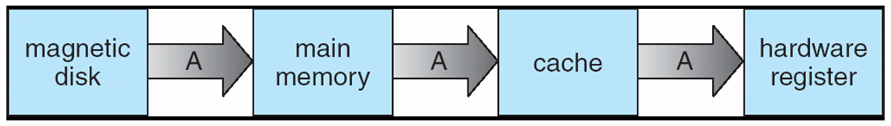

Multiprocessor environment must provide **cache coherency** in hardware such that all CPUs have the most recent value in their cache

**I/O Subsystem**

* One purpose of OS is to hide peculiarities of hardware devices from the user
  + Memory management of I/O including buffering (storing data temporarily while it is being transferred), caching (storing parts of data in faster storage for performance), spooling (the overlapping of output of one job with input of other jobs)
  + General device-driver interface
  + Drivers for specific hardware devices

**Protection and Security**

* **Protection** – any mechanism for **controlling** access of processes or users to resources defined by the OS 资源权限
* **Security** – defense of the system against internal and external *attacks 防范攻击！*
  + Huge range, including denial-of-service, worms, viruses, identity theft, theft of service

系统区分users的权限：

* + User identities (**user IDs**, security IDs) include name and associated number, one per user
  + User ID then associated with all files, processes of that user to determine access control
  + Group identifier (**group ID**) allows set of users to be defined and controls managed, then also associated with each process, file
  + **Privilege escalation** allows user to change to effective ID with more rights

**Kernel Data Structures**

链表，双链表，***Circular linked list，(Balanced) Binary search tree, Hash map, Bitmap***

**Computing Environments – Traditional 网络**

* Stand-alone general purpose machines
* But blurred as most systems interconnect with others (i.e. the Internet)
* **Portals** provide web access to internal systems （大门、入口）
* **Network computers** (**thin clients**) are like Web terminals
* Mobile computers interconnect via **wireless networks**
* Networking becoming ubiquitous – even home systems use **firewalls** to protect home computers from Internet attacks

**Computing Environments – Mobile 移动**

* Handheld smartphones, tablets, etc
* Extra feature – more OS features (GPS, gyroscope) 陀螺仪
* Allows new types of apps like ***augmented reality***
* Use IEEE 802.11 wireless, or cellular data networks for connectivity
* Leaders are **Apple iOS** and **Google Android**

**Computing Environments – Distributed 分布式**

* + Collection of separate, possibly heterogeneous, systems networked together
    - **Network** is a communications path, **TCP/IP** most common
      * **Local Area Network** (**LAN**)
      * **Wide Area Network** (**WAN**)
      * **Metropolitan Area Network** (**MAN**)
      * **Personal Area Network** (**PAN**)
  + **Network Operating System** provides features between systems across network
    - Communication scheme allows systems to exchange messages
    - Illusion of a single system

**Computing Environments – Client-Server 服务器，服务客户请求**

* Client-Server Computing
  + Dumb terminals supplanted by smart PCs
  + Many systems now **servers**, responding to requests generated by **clients**
    - **Compute-server system** provides an interface to client to request services (i.e., database)
    - **File-server system** provides interface for clients to store and retrieve files

1_18.pdf

**Computing Environments - Peer-to-Peer 分布式，端对端。对等网络**

1_19.pdf

* P2P does not distinguish clients and servers
  + Instead all nodes are considered peers
  + May each act as client, server or both
  + Node must join P2P network
    - Registers its service with central lookup service on network, or
    - Broadcast request for service and respond to requests for service via ***discovery protocol***
  + Examples includeNapsterandGnutella*,* **Voice over IP** *(***VoIP***)* such as Skype

**Computing Environments – Virtualization 这个很眼熟了吧~ 虚拟化**

* Use cases involve laptops and desktops running multiple OSes for exploration or compatibility
  + Apple laptop running Mac OS X host, Windows as a guest
  + Developing apps for multiple OSes without having multiple systems
  + QA testing applications without having multiple systems
  + Executing and managing compute environments within data centers
* VMM can run natively, in which case they are also the host
  + There is no general purpose host then (VMware ESX and Citrix XenServer)

**Computing Environments – Cloud Computing 呵呵**

* Delivers computing, storage, even apps as a service across a network
* Logical extension of virtualization as based on **virtualization**
  + Amazon **EC2** has thousands of servers, millions of VMs, PBs of storage available across the Internet, pay based on usage
* Many types
  + **Public cloud** – available via **Internet** to anyone willing to pay
  + **Private cloud** – run by a **company** for the company’s **own use**
  + **Hybrid cloud** – includes both public and private cloud components
  + Software as a Service (**SaaS**) – one or more applications available via the Internet (i.e. word processor)
  + Platform as a Service (**PaaS**) – software stack ready for application use via the Internet (i.e a **database** server)
  + Infrastructure as a Service (**IaaS**) – servers or storage available over Internet (i.e. storage available for backup use)
* Cloud compute environments composed of traditional OSes, plus VMMs, plus cloud management tools
  + Internet connectivity requires security like firewalls
  + **Load balancers** spread traffic across multiple applications

1_21.pdf

**Computing Environments – Real-Time Embedded Systems**

* + Vary considerable, special purpose, limited purpose OS, **real-time OS**
  + Use expanding
  + Processing ***must*** be done within constraint
  + Correct operation only if constraints met

**Open-Source Operating Systems**

* **Operating systems made available in source-code format rather than just binary closed-source**
* **Counter to the copy protection and Digital Rights Management (DRM) movement**
* **Started by Free Software Foundation (FSF), which has “copyleft” GNU Public License (GPL) （Apache**
* **Examples include GNU/Linux and BSD UNIX (including core of Mac OS X), and many more**

**Can use VMM like VMware Player (Free on Windows), Virtualbox**

* + **Use to run guest operating systems for exploration**

Cha2: System Structure

OS: 执行程序&服务的环境

* + **User interface** - Almost all operating systems have a user interface (**UI**). 用户界面
    - Varies between **Command-Line (CLI)**, **Graphics User Interface (GUI)**, **Batch**
  + **Program execution** - The system must be able to load a program into memory and to run that program, end execution, either normally or abnormally (indicating error)
  + **I/O operations** - A running program may require I/O, which may involve a file or an I/O device
  + **File-system manipulation** - The file system is of particular interest. Programs need to read and write files and directories, create and delete them, search them, list file Information, permission management.

**1 Communications** – Processes may exchange information, on the same computer or between computers over a network

* + - Communications may be via **shared memory** or through **message passing** (packets moved by the OS)

**1 Error detection** – OS needs to be constantly aware of possible errors 可以在硬件，CPU，内存，I/O，user程序发生。特定处理error

* + - **Debugging facilities** can greatly enhance the user’s and programmer’s abilities to efficiently use the system
  1. **Resource allocation -** When multiple users or multiple jobs running concurrently, resources must be allocated to each of them
     + Many types of resources - Some (such as CPU cycles, main memory, and file storage) may have special allocation code, others (such as I/O devices) may have general request and release code
  2. **Accounting -** To keep track of which users use **how much and what kinds of computer resources**
  3. **Protection and security -** The owners of information stored in a multiuser or networked computer system may want to control use of that information, concurrent processes should not interfere with each other
     + **Protection** involves ensuring that **all access to system resources is controlled**
     + **Security** of the system from outsiders requires **user authentication**, extends to defending external I/O devices from invalid access attempts
     + If a system is to be **protected and secure,** precautions防范 must be instituted throughout it. A chain is only as strong as its weakest link.

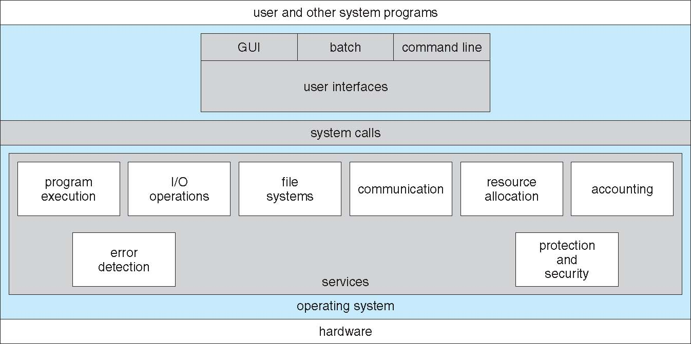

* UI: CLI or **command interpreter** allows direct command entry
  + - Sometimes implemented in kernel, sometimes by systems program
    - Sometimes multiple flavors implemented – **shells**
    - Primarily fetches a command from user and executes it
      * Sometimes commands built-in, sometimes just names of programs
        + If the latter, adding new features doesn’t require shell modification

GUI: 桌面，**Icons** represent files, programs, actions Various mouse buttons over objects in the interface cause various actions (provide information, options, execute function, open directory (known as a **folder**) 图像界面。

* + Microsoft Windows is GUI with CLI “command” shell
  + Apple Mac OS X is “Aqua” GUI interface with UNIX kernel underneath and shells available
  + Unix and Linux have CLI with optional GUI interfaces (CDE, KDE, GNOME)

Touchscreen：gestures，virtual keyboard

**System Calls**

* Programming interface to the **services** provided by the **OS**
* Typically written in a high-level language (C or C++)
* Mostly accessed by programs via a high-level **Application Program Interface (API)** rather than direct system call use 更高层API
* Three most common APIs are Win32 API for Windows, POSIX API for POSIX-based systems (including virtually all versions of UNIX, Linux, and Mac OS X), and Java API for the Java virtual machine (JVM)

**System Call Implementation**

* Typically, **a number** associated with each system call 每个system call对应一个编号
  + **System-call interface** maintains a **table indexed** according to these numbers
* The system call interface invokes intended system call in OS kernel and returns **status** of the system call and any **return values**

Caller不用知道system怎么implement的，封装抽象

* + Just needs to obey **API** and understand what OS will do as a result call
  + Most details of OS interface hidden from programmer by API
    - Managed by run-time support library (set of functions built into libraries included with compiler)

**API – System Call – OS Relationship user和kernel mode的切换**

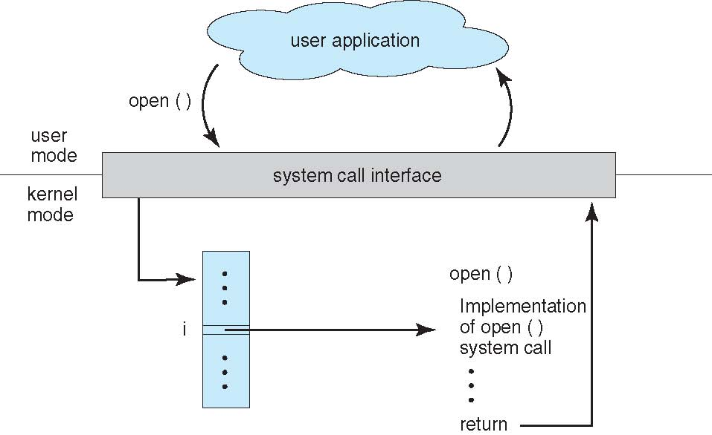 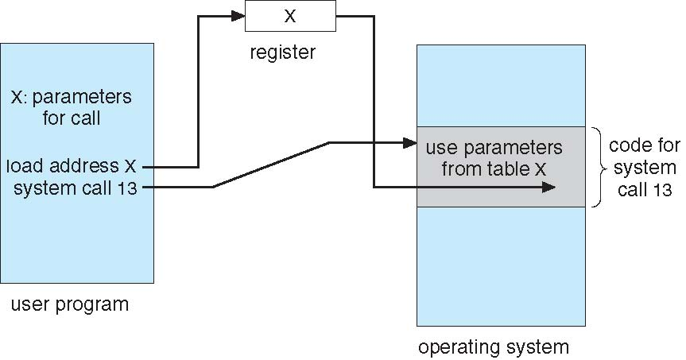

**System Call Parameter Passing**

* Often, more information is required than simply identity of desired system call
  + Exact type and amount of information vary according to OS and call
* Three general methods used to pass parameters to the OS
  + Simplest: pass the parameters in **registers**
    - In some cases, may be more parameters than registers
  + Parameters stored in a block*,* or table, in memory, and **address of block** passed as a parameter in a register
    - This approach taken by Linux and Solaris 传输表地址，存在表里面
  + Parameters placed, or **pushed***,* onto the **stack**by the program and **popped**off the stack by the operating system 存在栈里面
  + Block and stack methods do not limit **the number or length of parameters** being passed

**Types of System Calls**

* Process control
  + end, abort
  + load, execute
  + create process, terminate process
  + get process attributes, set process attributes
  + wait for time
  + wait event, signal event
  + allocate and free memory
  + Dump memory if error
  + **Debugger** for determining **bugs, single step** execution
  + **Locks** for managing access to shared data between processes
* File management
  + create file, delete file
  + open, close file
  + read, write, reposition
  + get and set file attributes
* Device management
  + request device, release device
  + read, write, reposition
  + get device attributes, set device attributes
  + logically attach or detach devices
* Information maintenance
  + get time or date, set time or date
  + get system data, set system data
  + get and set process, file, or device attributes
* Communications
  + create, delete communication connection
  + send, receive messages if **message passing model** to **host name** or **process name**
    - From **client** to **server**
  + **Shared-memory model** create and gain access to memory regions
  + transfer status information
  + attach and detach remote devices
* Protection
  + Control **access to resources**
  + Get and set permissions
  + Allow and deny user access
* C program invoking printf() library call, which calls write() system call

**Example: FreeBSD**

* **Unix variant**
* **Multitasking**
* **User login -> invoke user’s choice of shell**
* **Shell executes fork() system call to create process**
  + **Executes exec() to load program into process**
  + **Shell waits for process to terminate or continues with user commands**
* **Process exits with code of 0 – no error or > 0 – error code**

MS-DOS

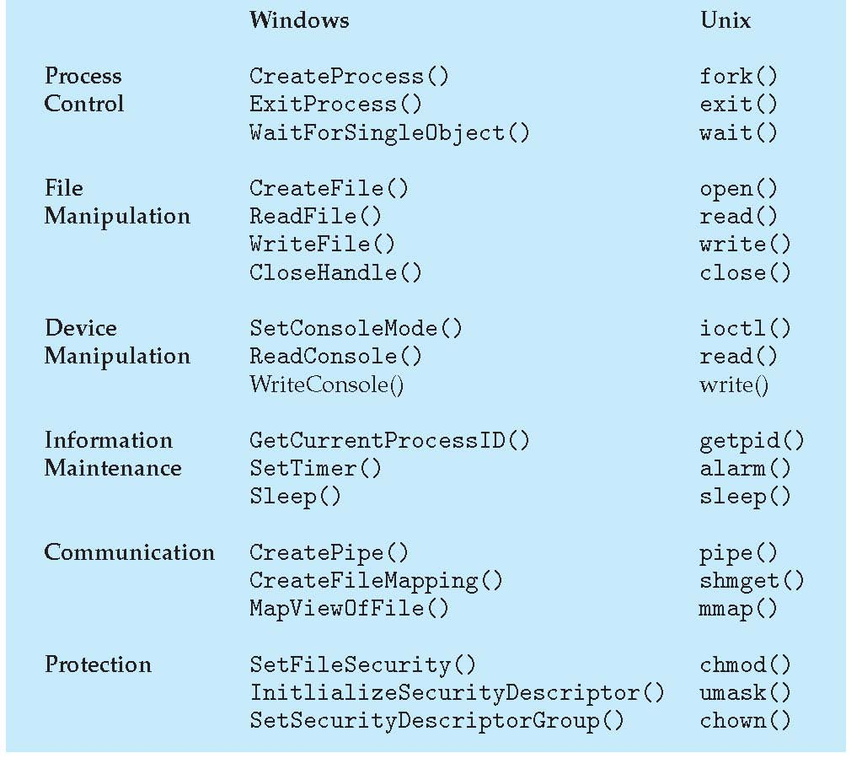 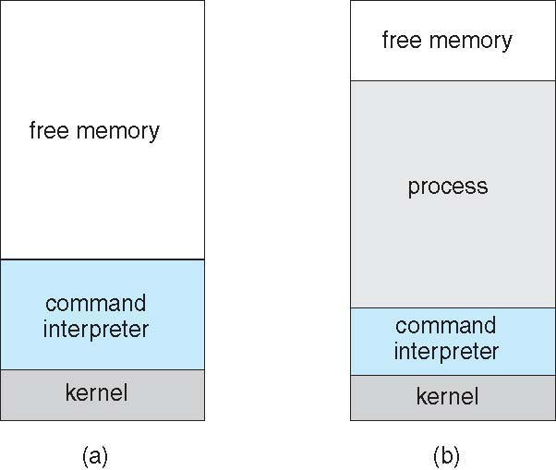

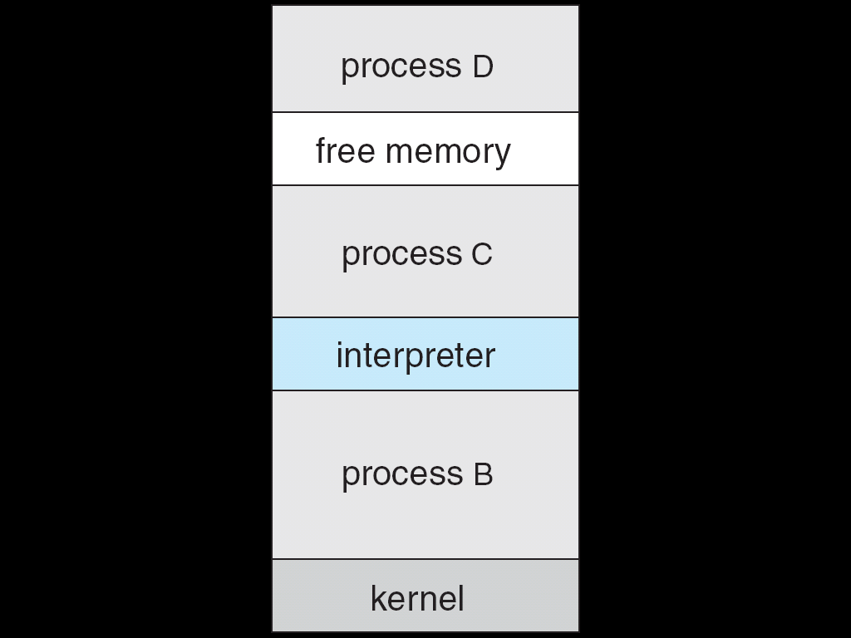

**System Programs**

* System programs provide a convenient environment for program development and execution. They can be divided into:
  + **File manipulation**
  + **Status information sometimes stored in a File modification**
  + **Programming language support**
  + **Program loading and execution**
  + **Communications**
  + **Background services**
  + **Application programs**
* Most users’ view of the operation system is defined by system programs, not the actual system calls

实现的功能，而不是system call

* Provide a convenient environment for program development and execution
  + Some of them are **simply user interfaces to system calls**; others are considerably **more complex**
* **File management** - Create, delete, copy, rename, print, dump, list, and generally manipulate files and directories
* **Status information**
  + Some ask the system for info - date, time, amount of available memory, disk space, number of users
  + Others provide detailed performance, logging, and debugging information
  + Typically, these programs format and print the output to the terminal or other output devices
  + Some systems implement a **registry** - used to store and retrieve configuration information
* **File modification**
  + Text editors to create and modify files
  + Special commands to search contents of files or perform transformations of the text
* **Programming-language support** - Compilers, assemblers, debuggers and interpreters sometimes provided
* **Program loading and execution**- Absolute loaders, relocatable loaders, linkage editors, and overlay-loaders, debugging systems for higher-level and machine language
* **Communications** - Provide the mechanism for creating virtual connections among processes, users, and computer systems
  + Allow users to send messages to one another’s screens, browse web pages, send electronic-mail messages, log in remotely, transfer files from one machine to another
* **Background Services**
  + Launch at boot time
    - Some for system startup, then terminate
    - Some from system boot to shutdown
  + Provide facilities like disk checking, process scheduling, error logging, printing
  + Run in **user context** not kernel context
  + Known as **services**, **subsystems**, **daemons** 守护进程
* **Application programs**
  + Don’t pertain to system
  + Run by users
  + Not typically considered part of OS
  + Launched by command line, mouse click, finger poke

用户语境，非内核语境。服务，子系统，守护进程。

**Operating System Design and Implementation**

变化多样。硬件，系统选择。

* **User** goals and **System** goals
  + User goals – operating system should be convenient to use, easy to learn, reliable, safe, and fast
  + System goals – operating system should be easy to design, implement, and maintain, as well as flexible, reliable, error-free, and efficient
* Important principle to separate

**Policy: *What*** will be done? **Mechanism: *How*** to do it?

* + The separation of policy from mechanism is a very important principle, it allows maximum flexibility if policy decisions are to be changed later
* Specifying and designing OS is highly creative task of **software engineering**
* Much variation
  + Early OSes in assembly language
  + Then system programming languages like Algol, PL/1
  + Now C, C++
* Actually usually a mix of languages
  + Lowest levels in assembly
  + Main body in C
  + Systems programs in C, C++, scripting languages like PERL, Python, shell scripts
* More high-level language easier to **port** to other hardware
  + But slower
* **Emulation** can allow an **OS to run on non-native hardware 仿真：在非本地硬件上跑**
* General-purpose OS is very large program

**Simple Structure**

* I.e. MS-DOS – written to provide the most functionality in the least space
  + Not divided into modules
  + Although MS-DOS has some structure, its interfaces and levels of functionality are not well separated

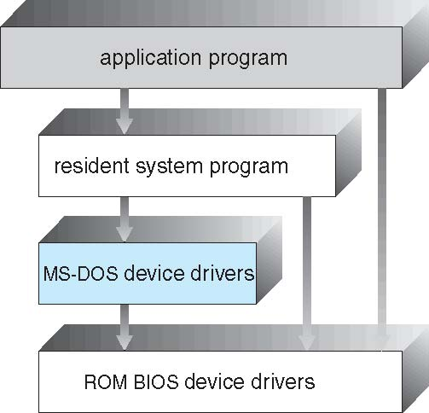 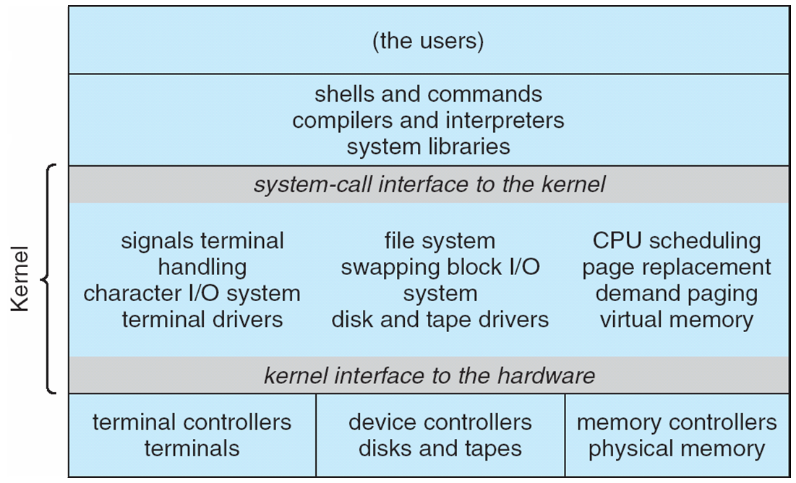

* UNIX – limited by hardware functionality, the original UNIX operating system had limited structuring. The UNIX OS consists of two separable parts
  + Systems programs
  + The kernel
    - Consists of everything below the system-call interface and above the physical hardware
    - Provides the file system, CPU scheduling, memory management, and other operating-system functions; a large number of functions for one level

Better！ Beyond simple but not fully layered

**Layered Approach**

* The operating system is divided into a number of layers (levels), each built on top of lower layers. The bottom layer (layer 0), is the hardware; the highest (layer N) is the user interface.
* With modularity, layers are selected such that each uses functions (operations) and services of only lower-level layers

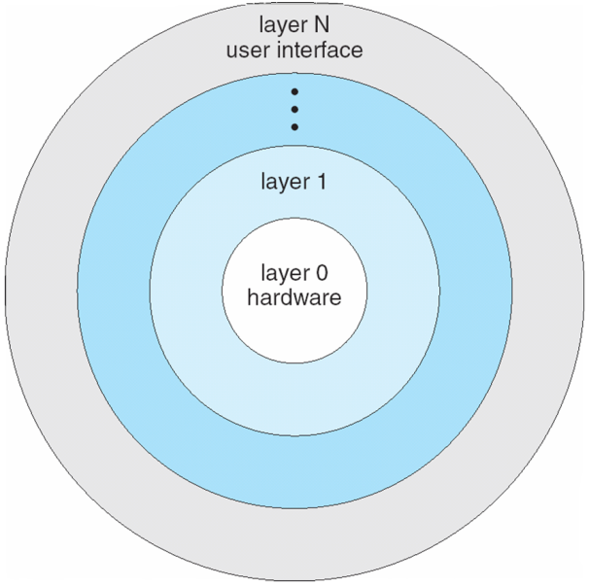

**Microkernel System Structure**

* Moves as much from the kernel into user space
* **Mach** example of **microkernel**
  + Mac OS X kernel (**Darwin**) partly based on Mach
* Communication takes place between user modules using **message passing**
* Benefits:
  + Easier to **extend** a microkernel
  + Easier to **port** the operating system to new architectures
  + More reliable (less code is running in kernel mode)
  + More secure
  + Detriments:
  + Performance overhead of user space to kernel space communication

2_14.pdf 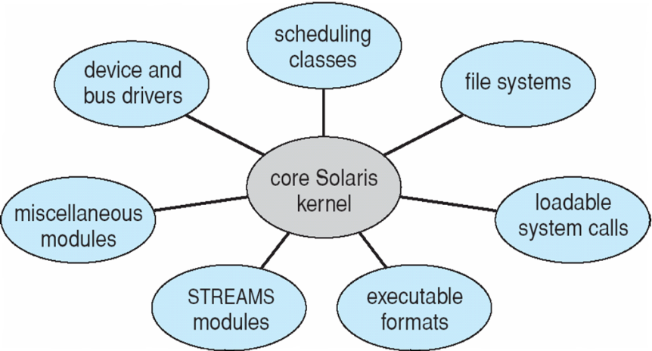

**Modules kernel组件模块化**

* Most modern operating systems implement **loadable** **kernel modules**
  + Uses **object-oriented** approach
  + Each core component is separate
  + Each talks to the others over known interfaces
  + Each is loadable as needed within the kernel
* Overall, similar to layers but with more flexible
  + Linux, Solaris, etc

**Hybrid Systems 组合**

* Most modern operating systems actually not one pure model
  + Hybrid combines multiple approaches to address performance, security, usability needs
  + Linux and Solaris kernels in kernel address space, so monolithic单块集成, plus modular for dynamic loading of functionality
  + Windows mostly monolithic, plus microkernel for different subsystem ***personalities***
* Apple Mac OS X hybrid, layered, **Aqua** UI plus **Cocoa** programming environment
  + Below is kernel consisting of Mach microkernel and BSD Unix parts, plus I/O kit and dynamically loadable modules (called **kernel extensions**)

2_16.pdf

**iOS**

* Apple mobile OS for ***iPhone***, ***iPad***
  + Structured on Mac OS X, added functionality
  + Does not run OS X applications natively
    - Also runs on different CPU architecture (ARM vs. Intel)
  + **Cocoa Touch** Objective-C API for developing apps
  + **Media services** layer for graphics, audio, video
  + **Core services** provides cloud computing, databases
  + Core operating system, based on Mac OS X kernel

**Android**

* Developed by **Open Handset Alliance** (mostly Google)
  + Open Source
* Similar stack to IOS
* Based on Linux kernel but modified
  + Provides process, memory, device-driver management
  + Adds power management
* Runtime environment includes core set of libraries and Dalvik virtual machine
  + Apps developed in Java plus Android API
    - Java class files compiled to Java bytecode then translated to executable than runs in Dalvik VM
* Libraries include **frameworks for web browser** (webkit), database (SQLite), multimedia, smaller libc

**Android Architecture**

2_18.pdf

**Operating-System Debugging**

* **Debugging** is finding and fixing errors, or **bugs**
* OSes generate **log files** containing error information
* **Failure of an application** can generate **core dump** file capturing memory of the process 核心转储
* **Operating system failure** can generate **crash dump** file containing kernel memory 故障转储
* Beyond crashes, performance tuning can optimize system performance
  + Sometimes using ***trace listings*** of activities, recorded for analysis
  + **Profiling** **is periodic sampling of instruction** pointer to look for **statistical trends** 资料收集
* **Kernighan’s Law: “Debugging is twice as hard as writing the code in the first place. Therefore, if you write the code as cleverly as possible, you are, by definition, not smart enough to debug it**.”

**Performance Tuning**

* Improve performance by removing bottlenecks
* OS must provide means of computing and displaying measures of system behavior
* For example, “top” program or Windows Task Manager

**DTrace**

* DTrace tool in Solaris, FreeBSD, Mac OS X allows live instrumentation on production systems生产系统
  + **Probes** fire when code is executed within a **provider**, capturing state data and sending it to **consumers** of those probes
* DTrace code to record amount of time each process with UserID 101 is in running mode (on CPU) in nanoseconds

**Operating System Generation**

* Operating systems are designed to run on any of a class of machines; the system must be configured for each specific computer site
* **SYSGEN** program obtains information concerning the **specific configuration of the hardware system**
  + Used to build system-specific compiled kernel or system-tuned
  + Can generate more efficient code than one general kernel

**System Boot**

* When power initialized on system, execution starts at a fixed memory location
  + **Firmware ROM** used to hold initial boot code
* Operating system must be made available to hardware so hardware can start it
  + Small piece of code – **bootstrap loader**, stored in **ROM** or **EEPROM** locates the kernel, loads it into memory, and starts it
  + 引导装入程序
  + Sometimes two-step process where **boot block** at fixed location loaded by ROM code, which loads bootstrap loader from disk
* Common bootstrap loader, **GRUB**, allows selection of kernel from multiple disks, versions, kernel options
* Kernel loads and system is then **running**

Cha3: Process Concept

* + Batch system – **jobs (process)**
  + Time-shared systems – **user programs** or **tasks**
* **Process** – a program in execution; process execution must progress in sequential fashion
  + The program code, also called **text section**
  + Current activity including **program counter**, processor registers
  + **Stack** containing temporary data
    - Function parameters, return addresses, local variables
  + **Data section** containing global variables
  + **Heap** containing memory dynamically allocated during run time
* Program is ***passive*** entity stored on disk (**executable file**), process is ***active*** 
  + Program becomes process when executable file loaded into memory

Execution of program started via GUI mouse clicks, command line entry of its name,

* One program can be several processes
  + Consider multiple users executing the same program

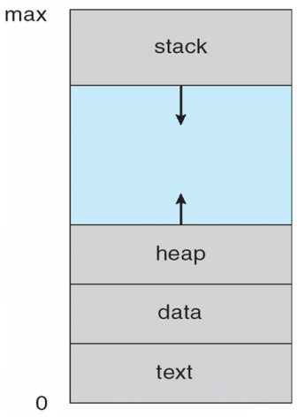 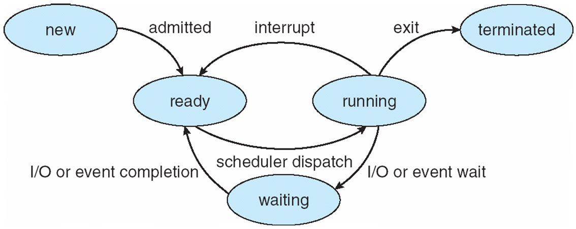

* As a process executes, it changes **state**
  + **new**: The process is being created
  + **running**: Instructions are being executed
  + **waiting**: The process is waiting for some event to occur
  + **ready**: The process is waiting to be assigned to a processor
  + **terminated**: The process has finished execution

**Process Control Block (PCB)**

Information associated with each process

(also called **task control block**)

* Process state – running, waiting, etc
* Program counter – location of instruction to next execute
* CPU registers – contents of all process-centric registers
* CPU scheduling information- priorities, scheduling queue pointers
* Memory-management information – memory allocated to the process
* Accounting information – CPU used, clock time elapsed since start, time limits
* I/O status information – I/O devices allocated to process, list of open files

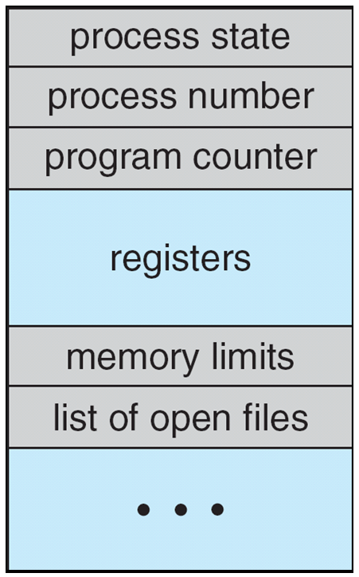 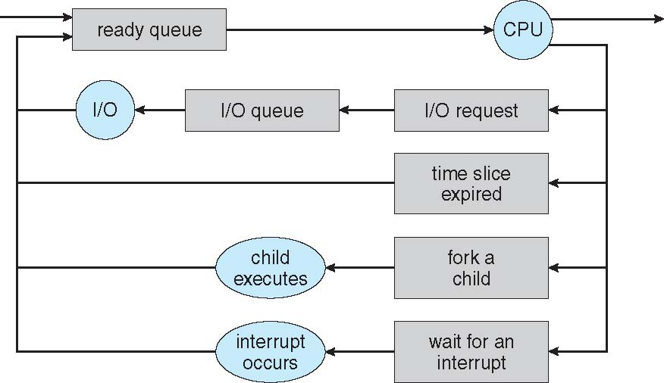

**Threads**

* So far, process has a single thread of execution
* Consider having multiple program counters per process
  + Multiple locations can execute at once
    - Multiple threads of control -> **threads**

Must then have storage for thread details, multiple program counters in PCB

Linux: C struct 指针

**Process Scheduling**

* Maximize CPU use, quickly switch processes onto CPU for time sharing
* **Process scheduler** selects among available processes for next execution on CPU
* Maintains **scheduling queues** of processes
  + **Job queue** – set of all processes in the system
  + **Ready queue** – set of all processes residing in main memory, ready and waiting to execute
  + **Device queues** – set of processes waiting for an I/O device
  + Processes migrate among the various queues
* **Representation of Process Scheduling**
* **Queuing diagram** represents queues, resources, flows

**Schedulers**

* **Long-term scheduler** (or **job scheduler**) – selects which processes should be brought into the ready queue 不频繁
* **Short-term scheduler** (or **CPU scheduler**) – selects which process should be executed next and allocates CPU 频繁调用
  + Sometimes the only scheduler in a system
* The long-term scheduler controls the **degree of multiprogramming**
* Processes can be described as either:
  + **I/O-bound process** – spends more time doing I/O than computations, many short CPU bursts
  + **CPU-bound process** – spends more time doing computations; few very long CPU bursts
* Long-term scheduler strives for good ***process mix***

**Addition of Medium Term Scheduling**

* **Medium-term scheduler** can be added if degree of multiple programming needs to decrease
  + Remove process from memory, store on disk, bring back in from disk to continue execution: **swapping**

交换

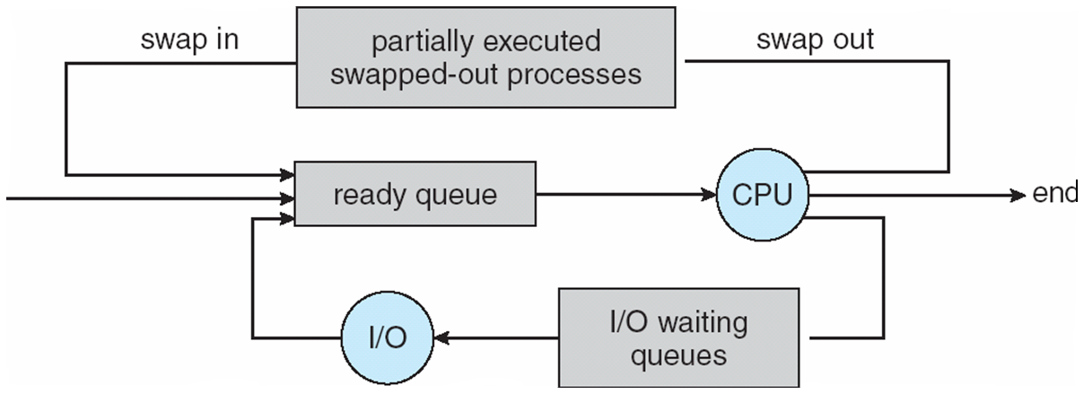

**Multitasking in Mobile Systems**

* Some systems / early systems allow only one process to run, others suspended
* Due to screen real estate, user interface limits iOS provides for a
  + Single **foreground** process- controlled via user interface
  + Multiple **background** processes– in memory, running, but not on the display, and with limits
  + Limits include single, short task, receiving notification of events, specific long-running tasks like audio playback
* Android runs foreground and background, with fewer limits
  + Background process uses a **service** to perform tasks
  + Service can keep running even if background process is suspended
  + Service has no user interface, small memory use

**Context Switch**

* When CPU switches to another process, the system must **save the state** of the old process and load the **saved state** for the new process via a **context switch**
* **Context** of a process represented in the PCB
* Context-switch time is overhead; the system does no useful work while switching
  + The more complex the OS and the PCB -> longer the context switch
* Time dependent on hardware support
  + Some hardware provides multiple sets of registers per CPU -> multiple contexts loaded at once

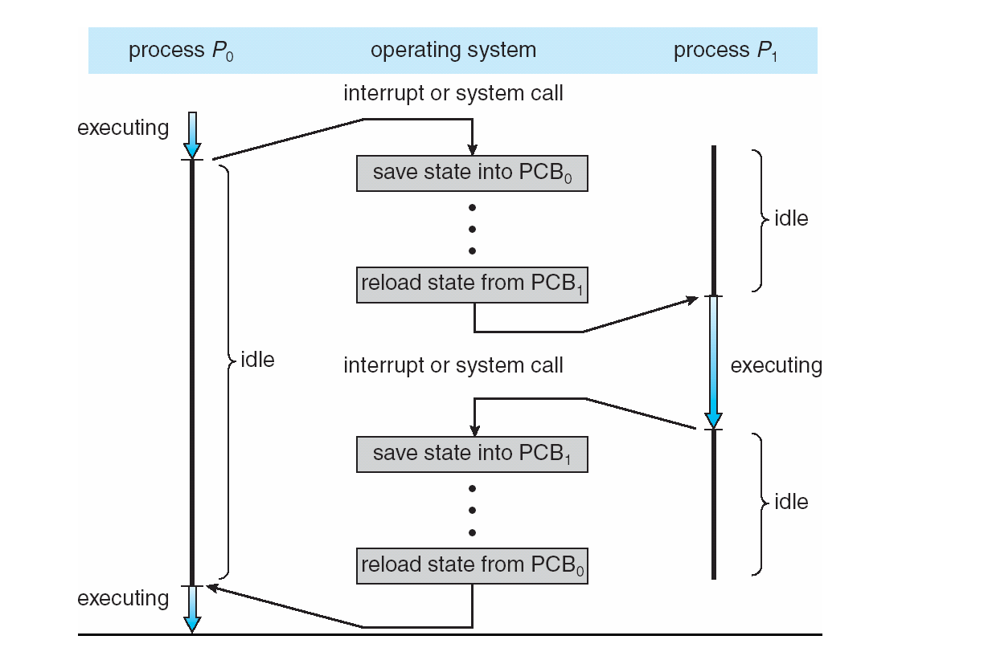

**Process Creation**

* **Parent** process create **children** processes, which, in turn create other processes, forming a **tree** of processes
* Generally, process identified and managed via a **process identifier** (**pid**)
* Resource sharing options
  + Parent and children share all resources
  + Children share subset of parent’s resources
  + Parent and child share no resources
  + Execution options
  + Parent and children execute concurrently
  + Parent waits until children terminate
* Address space
  + Child duplicate of parent
  + Child has a program loaded into it
* UNIX examples
  + **fork()** system call creates new process
  + **exec()** system call used after a **fork()** to replace the process’ memory space with a new program

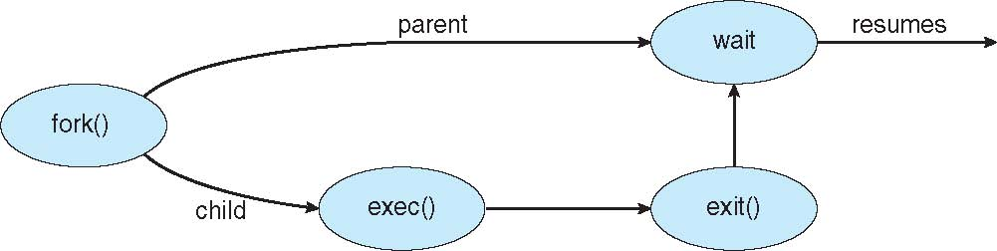

**Process Termination**

* Process executes last statement and asks the operating system to delete it (**exit()**)
  + Output data from child to parent (via **wait()**)
  + Process’ resources are deallocated by operating system

Parent may terminate execution of children processes (**abort()**)

* + Child has exceeded allocated resources
  + Task assigned to child is no longer required
  + If parent is exiting
    - Some operating systems do not allow child to continue if its parent terminates
      * All children terminated - **cascading termination**

Wait for termination, returning the pid:

* If no parent waiting, then terminated process is a **zombie**
* If parent terminated, processes are **orphans**

浏览器

* Many web browsers ran as single process (some still do)

If one web site causes trouble, entire browser can hang or crash

* Google Chrome Browser is multiprocess with 3 categories
  + **Browser** process manages user interface, disk and network I/O
  + **Renderer** process renders web pages, deals with HTML, Javascript, new one for each website opened
    - Runs in **sandbox** restricting disk and network I/O, minimizing effect of security exploits
  + **Plug-in** process for each type of plug-in

**Interprocess Communication**

* Processes within a system may be ***independent*** or ***cooperating***
* ***Independent*** process cannot affect or be affected by the execution of another process
* ***Cooperating*** process can affect or be affected by other processes, including sharing data
* Reasons for cooperating processes:
  + Information sharing
  + Computation speedup
  + Modularity
  + Convenience
* Cooperating processes need **interprocess communication** (**IPC**)
* Two models of IPC
  + **Shared memory**
  + **Message passing**

3_12.pdf

**Producer-Consumer Problem 生产商提供信息，顾客消费**

* Paradigm for cooperating processes, *producer* process produces information that is consumed by a *consumer* process
  + **unbounded-buffer** places no practical limit on the size of the buffer
  + **bounded-buffer** assumes that there is a fixed buffer size

**Interprocess Communication – Message Passing**

* Mechanism for processes to communicate and to synchronize their actions
* Message system – processes communicate with each other without resorting to shared variables
* IPC facility provides two operations:
  + **send**(*message*) – message size fixed or variable
  + **receive**(*message*)
  + If *P* and *Q* wish to communicate, they need to
  + establish a ***communication* *link*** between them
  + exchange messages via send/receive
  + Implementation of communication link
  + physical (e.g., shared memory, hardware bus)
  + logical (e.g., direct or indirect, synchronous or asynchronous, automatic or explicit buffering)

**Direct Communication**

* Processes must name each other explicitly
  + **send** (*P, message*) – send a message to process P
  + **receive**(*Q, message*) – receive a message from process Q

Properties of communication link

* + Links are established **automatically**
  + **A link is associated with exactly one pair of communicating processes**
  + Between **each pair there exists exactly one link**
  + The link may be unidirectional, but is usually bi-directional

**Indirect Communication (1)**

* Messages are directed and received from mailboxes (also referred to as ports)
  + Each mailbox has a unique id
  + Processes can communicate only if they share a mailbox
  + Properties of communication link
  + Link established only if processes share a common mailbox
  + A link may be associated with many processes
  + Each pair of processes may share several communication links
  + Link may be unidirectional or bi-directional

**Indirect Communication (2)**

* Operations
  + create a new mailbox
  + send and receive messages through mailbox
  + destroy a mailbox
  + Primitives are defined as
  + **send**(*A, message*) – send a message to mailbox A
  + **receive**(*A, message*) – receive a message from mailbox A

**Indirect Communication (3)**

* Mailbox sharing
  + *P1, P2,* and *P3* share mailbox A
  + *P1*, sends; *P2* and *P3* receive
  + Who gets the message?
  + Solutions
  + Allow a link to be associated with at most two processes
  + Allow only one process at a time to execute a receive operation
  + Allow the system to select arbitrarily the receiver. Sender is notified who the receiver was

**Synchronization (1)**

* Message passing may be either blocking or non-blocking

**Blocking** is considered **synchronous**

* + Blocking send has the sender block until the message is received
  + **Blocking receive** has the receiver block until a message is available

**Non-blocking** is considered **asynchronous**

* + **Non-blocking** send has the sender send the message and continue
  + **Non-blocking** receive has the receiver receive a valid message or null
* Different combinations possible
  + If both send and receive are blocking, we have a **rendezvous**

**Buffering 根据sender的等候状态分类**

* Queue of messages attached to the link; implemented in one of three ways

1. **Zero capacity** – 0 messages  
Sender must wait for receiver (rendezvous)

2. **Bounded capacity** – finite length of *n* messages  
Sender must wait if link full

3. **Unbounded capacity** – infinite length   
Sender never waits

**Examples of IPC Systems – Windows LPC？**

* Message-passing centric via **advanced local procedure call (LPC)** facility
  + Only works between processes on the same system
  + Uses ports (like mailboxes) to establish and maintain communication channels
  + Communication works as follows
    - The client opens a handle to the subsystem’s **connection port** object.
    - The client sends a connection request.
    - The server creates two private **communication ports** and returns the handle to one of them to the client.
    - The client and server use the corresponding port handle to send messages or callbacks and to listen for replies.

**Local Procedure Calls in Windows XP**

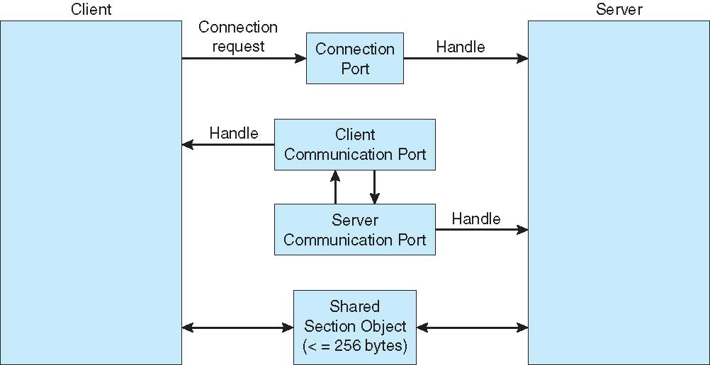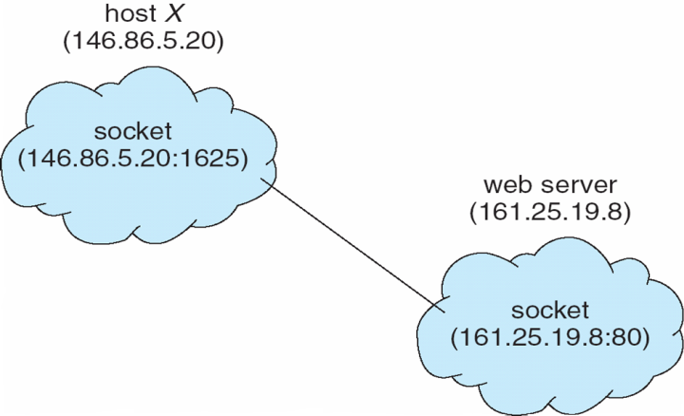

**Communications in Client-Server Systems 顾客-服务器机**

* Sockets
* Remote Procedure Calls
* Pipes
* Remote Method Invocation (Java)

**Sockets**

* A **socket** is defined as an endpoint for communication
* Concatenation of IP address and **port** – a number included at start of message packet to differentiate network services on a host
* The socket **161.25.19.8:1625** refers to port **1625** on host **161.25.19.8**
* Communication consists between a pair of sockets
* All ports below 1024 are ***well known***, used for standard services
* Special IP address 127.0.0.1 (**loopback**) to refer to system on which process is running
* Three types of sockets
  + **Connection-oriented** (**TCP**)
  + **Connectionless** (**UDP**)
  + **Multicast Socket** class– data can be sent to multiple recipients

**Remote Procedure Calls 愣是没太看懂**

* Remote procedure call (RPC) abstracts procedure calls between processes on networked systems
  + Again uses ports for service differentiation
* **Stubs** – client-side proxy for the actual procedure on the server
* The client-side stub locates the server and **marshalls** the parameters
* The server-side stub receives this message, unpacks the marshalled parameters, and performs the procedure on the server
* On Windows, stub code compile from specification written in **Microsoft Interface Definition Language** (**MIDL**)
* Data representation handled via **External Data Representation** (**XDL**) format to account for different architectures
  + **Big-endian** and **little-endian**
* Remote communication has more failure scenarios than local
  + Messages can be delivered ***exactly once*** rather than ***at most once***
* OS typically provides a rendezvous (or **matchmaker**) service to connect client and server

**Pipes**

* Acts as a conduit allowing two processes to communicate

**Ordinary Pipes**

* Ordinary Pipesallow communication in standard producer-consumer style
* Producer writes to one end (the **write-end** of the pipe)
* Consumer reads from the other end (the **read-end**of the pipe)
* Ordinary pipes are therefore unidirectional
* Require parent-child relationship between communicating processes
* Windows calls these **anonymous pipes**

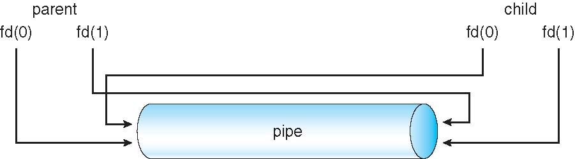

**Named Pipes**

* Named Pipes are more powerful than ordinary pipes
* Communication is bidirectional
* No parent-child relationship is necessary between the communicating processes
* Several processes can use the named pipe for communication
* Provided on both UNIX and Windows systems

**Chapter 4: Multithreaded Programming**

* Most modern applications are multithreaded
* Threads run within application
* Multiple tasks with the application can be implemented by separate threads
  + Update display
  + Fetch data
  + Spell checking
  + Answer a network request
* Process creation is heavy-weight while thread creation is light-weight
* Can simplify code, increase efficiency
* Kernels are generally multithreaded

**Process vs. Thread 共享内存，全局变量，堆，IRQ，文件**

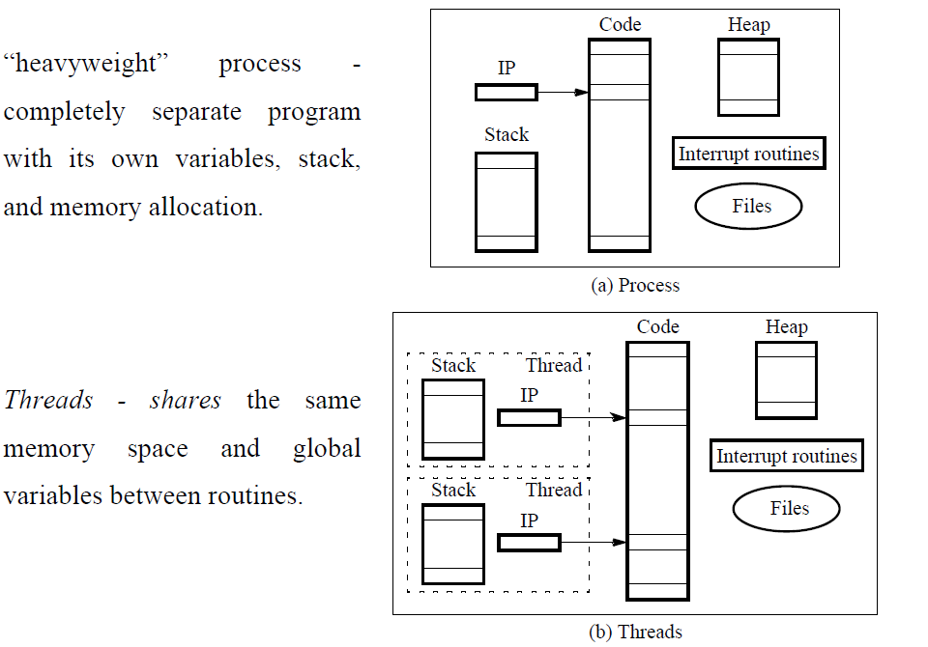

**Multithreaded Server Architecture**

4_02.pdf

**Benefits**

* **Responsiveness –** May allow continued execution if part of process is blocked, especially important for user interfaces
* **Resource Sharing –** Threads **share resources** of process, easier than shared memory or message passing
* **Economy –** Cheaper than process creation, thread switching lower overhead than context switching
* **Scalability –** Process can take advantage of multiprocessor architectures

**Multicore Programming**

* **Multicore** or **multiprocessor** systems putting pressure on programmers, challenges include:
  + Dividing activities
  + Balance
  + Data splitting
  + Data dependency
  + Testing and debugging
* ***Parallelism*** implies a system can perform more than one task simultaneously
* ***Concurrency*** supports more than one task making progress
  + Single processor/core, scheduler providing concurrency
* Types of parallelism
  + **Data parallelism** – Distributes **subsets of the same data** across multiple cores, same operation on each
  + **Task parallelism** – Distribute **threads across cores**, each thread performing unique operation
* As # of threads grows, so does architectural support for threading
  + CPUs have cores as well as ***hardware threads***
  + Consider Oracle SPARC T4 with 8 cores, and 8 hardware threads per core

**Concurrency vs. Parallelism**

4_03.pdf

**Parallelism on a multi-core system**

4_04.pdf

4_01.pdf

每个thread有自己的registers，stack

**Amdahl’s Law**

* Identifies performance gains from adding additional cores to an application that has both serial and parallel components
* *S* is serial portion
* *N* processing cores
* If application is 75% parallel / 25% serial, moving from 1 to 2 cores results in speedup of 1.6 times
* As *N* approaches infinity, speedup approaches 1 / *S*
  + Serial portion of an application has disproportionate effect on performance gained by adding additional cores
* But does the law take into account contemporary multicore systems?

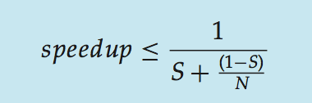

**User Threads and Kernel Threads**

* **User threads** - Management done by user-level threads library
* Three primary thread libraries:
  + POSIX **Pthreads**
  + Win32 threads
  + Java threads
* **Kernel threads** - Supported by the Kernel
* Examples – virtually all general purpose operating systems, including:
  + Windows
  + Solaris
  + Linux
  + Tru64 UNIX
  + Mac OS X

**Multithreading Models**

**Many-to-One**

* Many user-level threads mapped to single kernel thread
* One thread blocking causes all to block
* Multiple threads may not run in parallel on muticore system because only one may be in kernel at a time
* Few systems currently use this model
* Examples:
  + **Solaris Green Threads**
  + **GNU Portable Threads**

4_05.pdf4_06.pdf**4_07.pdf**

**One-to-One**

* Each user-level thread maps to kernel thread
* Creating a user-level thread creates a kernel thread
* More concurrency than many-to-one
* Number of threads per process sometimes restricted due to overhead
* Examples
  + Windows NT/XP/2000
  + Linux
  + Solaris 9 and later

**Many-to-Many Model**

* Allows many user level threads to be mapped to many kernel threads
* Allows the operating system to create a sufficient number of kernel threads
* Solaris prior to version 9
* Windows NT/2000 with the *ThreadFiber* package

**Two-level Model**

* Similar to M:M, except that it allows a user thread to be **bound** to kernel thread

**Thread Libraries**

* **Thread library** provides programmer with API for creating and managing threads
* Two primary ways of implementing
  + Library entirely in user space
  + Kernel-level library supported by the OS

**Pthreads (1)**

* May be provided either **as user-level or kernel-level**
* A POSIX standard (IEEE 1003.1c) API for thread creation and synchronization
* ***Specification***, not ***implementation***
* API specifies behavior of the **thread library**, implementation is up to development of the library
* Common in UNIX operating systems (Solaris, Linux, Mac OS X)

Join等待特定线程完成执行，非join的叫detached

指令执行顺序可能混乱

system routine

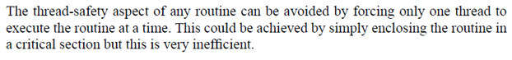

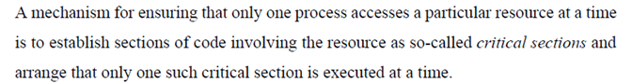

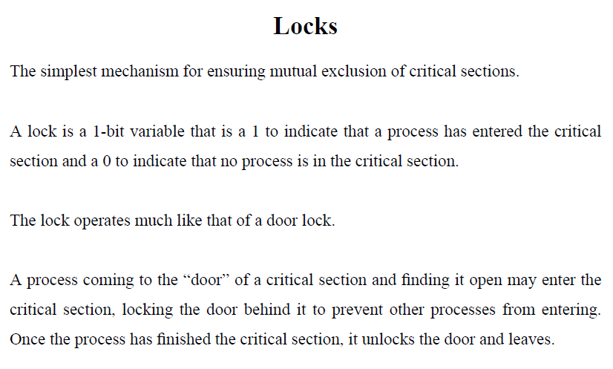

Mutex



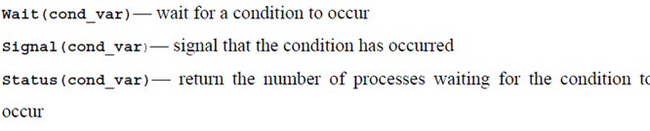

**Implicit Threading**

* Growing in popularity as numbers of threads increase, program correctness more difficult with **explicit threads**
* Creation and management of threads done by **compilers and run-time libraries** rather than programmers
* Three methods explored
  + Thread Pools
  + OpenMP
  + Grand Central Dispatch
* Other methods include Microsoft Threading Building Blocks (TBB), **java.util.concurrent** package

**Thread Pools**

* Create a number of **threads in a pool** where they await work
* Advantages
  + Usually slightly faster to **service** a request with an existing thread than **create** a new thread
  + Allows the number of threads in the application(s) to be bound to the size of the pool
  + Separating task to be performed from mechanics of creating task allows different strategies for running task
    - i.e.Tasks could be scheduled to **run periodically**
* Windows API supports thread pools

**OpenMP**

* Set of compiler directives and an API for C, C++, FORTRAN
* Provides support for parallel programming in **shared-memory** environments
* Identifies **parallel regions** – blocks of code that can run in parallel

**Grand Central Dispatch**

* Apple technology for Mac OS X and iOS operating systems
* Extensions to C, C++ languages, API, and run-time library
* Allows identification of **parallel sections**
* Manages most of the **details of threading**
* Block is in “^{ }” - **ˆ{ printf("I am a block"); }**
* Blocks placed in dispatch queue
  + Assigned to **available thread** in thread pool when removed from queue
* Two types of dispatch queues:
  + serial – blocks removed in FIFO order, queue is per process, called **main queue**
    - Programmers can create **additional serial queues** within program
  + concurrent – removed in FIFO order but several may be removed at a time
    - Three system wide queues with priorities low, default, high

**Threading Issues**

* Semantics of **fork()** and **exec()** system calls
* Signal handling
  + Synchronous and asynchronous
  + Thread cancellation of target thread
  + Asynchronous or deferred
  + Thread-local storage
  + Scheduler Activations

**Semantics of fork() and exec()**

* Does **fork()**duplicate only the calling thread or all threads?
  + Some UNIXes have two versions of fork
  + **Exec()** usually works as normal – **replace the running process** including all threads

**Signal Handling**

* **Signals** are used in UNIX systems to notify a process that a particular event has occurred.
* A **signal handler** is used to process signals
  1. Signal is generated by particular **event**
  2. Signal is delivered to a **process**
  3. Signal is handled by one of two signal handlers:
     1. default
     2. user-defined
* Every signal has **default handler** that **kernel** runs when handling signal
  1. **User-defined signal handler** can override default
  2. For single-threaded, signal delivered to process
* Where should a signal be delivered for multi-threaded?
  1. Deliver the signal to the thread to which the signal applies
  2. Deliver the signal to **every thread** in the process
  3. Deliver the signal to **certain threads** in the process
  4. Assign a specific thread to receive all signals for the process

**Thread Cancellation (1)**

* **Terminating a thread** before it has finished
* Thread to be canceled is **target thread**
* Two general approaches:
  + **Asynchronous cancellation** terminates the target thread immediately
  + **Deferred cancellation** allows the target thread to periodically check if it should be cancelled
* Invoking thread cancellation requests cancellation, but actual cancellation depends on thread state
* If thread has cancellation disabled, cancellation remains pending until thread enables it
* Default type is **deferred**
  + Cancellation only occurs when thread reaches **cancellation point**

Then **cleanup handler** is invoked

* On Linux systems, thread cancellation is handled through signals

**Thread-Local Storage**

* **Thread-local storage** (**TLS**) allows *each thread to have its own copy of data*
* Useful when you do not have control over the thread creation process (i.e., when using a thread pool)
* Different from local variables
  + Local variables visible only **during single function invocation**
  + TLS visible **across function invocations**
  + Similar to **static** data
  + **TLS is unique to each thread 每个线程特有的存储**

**Scheduler Activations**

* Both M:M and Two-level models require communication to maintain the appropriate number of kernel threads allocated to the application
* Typically use an intermediate data structure between user and kernel threads – **lightweight process** (**LWP**)
  + Appears to be a virtual processor on which process can schedule user thread to run
  + **Each LWP attached to kernel thread**
  + How many LWPs to create?
* Scheduler activations provide **upcalls** - a communication mechanism from the kernel to the **upcall handler** in the thread library
* This communication allows an application to maintain the correct number kernel threads 维持正确数量的kernel进程

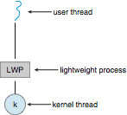 4_15.pdf

**Windows Threads**

* **one-to-one mapping, kernel-level**
* Each thread contains
  + A thread id
  + Register set representing state of processor
  + **Separate user and kernel stacks** for when thread runs in user mode or kernel mode
  + Private data storage area used by **run-time libraries and dynamic link libraries (DLLs)**
* The register set, stacks, and private storage area are known as the **context** of the thread
* The primary data structures of a thread include:
  + ETHREAD (executive thread block) – includes pointer to process to which thread belongs and to KTHREAD, in kernel space
  + KTHREAD (kernel thread block) – scheduling and synchronization info, kernel-mode stack, pointer to TEB, in kernel space
  + TEB (thread environment block) – thread id, user-mode stack, thread-local storage, in user space

**Linux Threads**

* Linux refers to them as ***tasks*** rather than ***threads***
* Thread creation is done through **clone()** system call
* **clone()** allows a child task to share the address space of the parent task (process)
  + Flags control behavior
  + **struct task\_struct** points to process data structures (shared or unique)

**Chapter 5: Process Scheduling**

* Maximum CPU utilization obtained with multiprogramming
* CPU–I/O Burst Cycle – Process execution consists of a **cycle** of CPU execution and I/O wait
* **CPU burst** followed by **I/O burst**
* **CPU burst** distribution is of main concern

**CPU Scheduler**

* **Short-term scheduler** selects from among the processes in ready queue, and allocates the CPU to one of them
  + Queue may be ordered in various ways
* CPU scheduling decisions may take place when a process:
  + Switches from running to waiting state
  + Switches from running to ready state
  + Switches from waiting to ready
  + Terminates
* Scheduling under 1 and 4 is **nonpreemptive**
* All other scheduling is **preemptive**
  + Consider access to shared data
  + Consider preemption while in kernel mode
  + Consider interrupts occurring during crucial OS activities

**Dispatcher**

* Dispatcher module gives control of the CPU to the process selected by the short-term scheduler; this involves:
  + Switching context
  + Switching to user mode
  + Jumping to the proper location in the user program to restart that program
  + **Dispatch latency** – Time for the dispatcher to stop one process and start another running

**Scheduling Criteria**

* **CPU utilization** – Keep the CPU as busy as possible
* **Throughput** – # of processes that complete their execution per time unit
* **Turnaround time** – Amount of time to execute a particular process
* **Waiting time** – Amount of time a process has been waiting in the ready queue
* **Response time** – Amount of time it takes from when a request was submitted until the first response is produced, not output (for time-sharing environment)

**Scheduling Algorithm Optimization Criteria**

* Max CPU utilization
* Max throughput
* Min turnaround time
* Min waiting time
* Min response time

**First-Come, First-Served (FCFS) Scheduling**

Waiting time是累加的. 平均等候时间是每个waiting time加起来/n 会有重复. 三个processes的话,只算两个wait

* **Convoy effect** - short process behind long process
  + Consider one CPU-bound and many I/O-bound processes

**Shortest-Job-First (SJF) Scheduling 最短等候时间? 注意到达次序**

* Associate with each process the length of its next CPU burst
  + Use these lengths to schedule the process with the shortest time
* SJF is optimal – gives minimum average waiting time for a given set of processes
  + The difficulty is knowing the length of the next CPU request
  + Could ask the user

**Determining Length of Next CPU Burst**

* Can only estimate the length – should be similar to the previous one
  + Then pick process with shortest predicted next CPU burst
* Can be done by using the length of previous CPU bursts, using exponential averaging
*  
* Commonly, α set to ½
* Preemptive version called **shortest-remaining-time-first**
* α =0
  + τn+1 = τn
  + Recent history does not count
* α =1
  + τn+1 = α *t*n
  + Only the actual last CPU burst counts
* If we expand the formula, we get:

τ*n*+1 = α t*n*+(1 *-* α*)*α *tn* -1+ …

*+(*1 - α *)j*α *tn* -*j* + …

*+(*1 - α *)n* +1 τ0

* Since both α and (1 - α) are less than or equal to 1, each successive term has less weight than its predecessor

**Priority Scheduling**

* A priority number (integer) is associated with each process
* The CPU is allocated to the process with the highest priority (smallest integer ≡ highest priority)
  + Preemptive
  + Nonpreemptive
  + SJF is priority scheduling where priority is the inverse of predicted next CPU burst time
* **Problem ≡ Starvation – low priority processes may never execute**
* **Solution ≡ Aging – as time progresses increase the priority of the process**

**Round Robin (RR) 轮流执行**

* Each process gets a small unit of CPU time (**time quantum** *q*), usually 10-100 milliseconds. After this time has elapsed, the process is preempted and added to the end of the ready queue.
* If there are *n* processes in the ready queue and the time quantum is *q*, then each process gets 1/*n* of the CPU time in chunks of at most *q* time units at once. No process waits more than (*n*-1)*q* time units.
* Timer interrupts every quantum to schedule next process
* Performance
  + *q* large ⇒ FIFO
  + *q* small ⇒ *q* must be large with respect to context switch, otherwise overhead is too high
* Typically, higher average turnaround than SJF, but better ***response***
* *q* should be large compared to context switch time
* *q* usually 10ms to 100ms, context switch < 10 usec

context switch: 切换进程运行

**80% of CPU bursts should be shorter than q**

**Multilevel Queue**

* Ready queue is partitioned into separate queues, eg:
  + **Foreground** (interactive)
  + **Background** (batch)
* Process permanently in a given queue
  + Each queue has its own scheduling algorithm:
  + Foreground – RR
  + Background – FCFS
  + Scheduling must be done between the queues
  + Fixed priority scheduling; (i.e., serve all from foreground then from background). Possibility of starvation.
  + Time slice – each queue gets a certain amount of CPU time which it can schedule amongst its processes; i.e., 80% to foreground in RR
  + 20% to background in FCFS

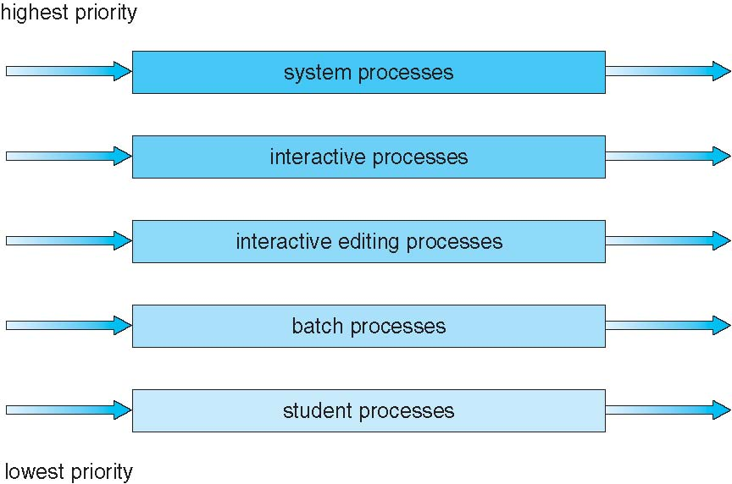

**Multilevel Feedback Queue**

* A process can move between the various queues; aging can be implemented this way
* Multilevel-feedback-queue scheduler defined by the following parameters
  + Number of queues
  + Scheduling algorithms for each queue
  + Method used to determine when to upgrade a process
  + Method used to determine when to demote a process
  + Method used to determine which queue a process will enter when that process needs service

**Thread Scheduling**

* Distinction between user-level and kernel-level threads
* When threads supported, threads scheduled, not processes
* Many-to-one and many-to-many models, thread library schedules user-level threads to run on LWP
  + Known as **process-contention scope (PCS)** since scheduling competition is within the process
  + Typically done via priority set by programmer
  + Kernel thread scheduled onto available CPU is **system-contention scope (SCS)** – competition among all threads in system

**Multiple-Processor Scheduling**

* CPU scheduling more complex when multiple CPUs are available
* **Homogeneous processors** within a multiprocessor
* **Asymmetric multiprocessing** – only one processor accesses the system data structures, alleviating the need for data sharing
* **Symmetric multiprocessing (SMP)** – each processor is self-scheduling, all processes in common ready queue, or each has its own private queue of ready processes
  + Currently, most common
* **Processor affinity** – process has affinity for processor on which it is currently running 进程和处理器的亲近性
  + **Soft affinity**
  + **Hard affinity**
  + Variations including **processor sets**

6_09.pdf

**Multiple-Processor Scheduling – Load Balancing**

* If SMP, need to keep all CPUs loaded for efficiency
* **Load balancing** attempts to keep workload evenly distributed
* **Push migration** – periodic task checks load on each processor, and if found pushes task from overloaded CPU to other CPUs
* **Pull migration** – idle processors pulls waiting task from busy processor

**Multicore Processors**

* Recent trend to place multiple processor cores on same physical chip
* Faster and consumes less power
* Multiple threads per core also growing
  + Takes advantage of memory stall to make progress on another thread while memory retrieve happens

**Multithreaded Multicore System**

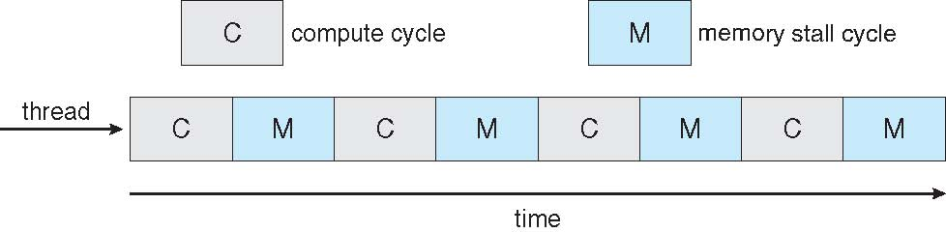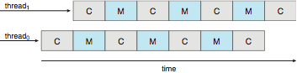

**Real-Time CPU Scheduling**

* **Soft real-time systems** – no guarantee as to when critical real-time process will be scheduled
* **Hard real-time systems** – task must be serviced by its deadline
* Two types of latencies affect performance
  1. Interrupt latency – time from **arrival of interrupt** to start of routine that services interrupt
  2. Dispatch latency – time for scheduler to **take current process** off CPU and **switch to** another

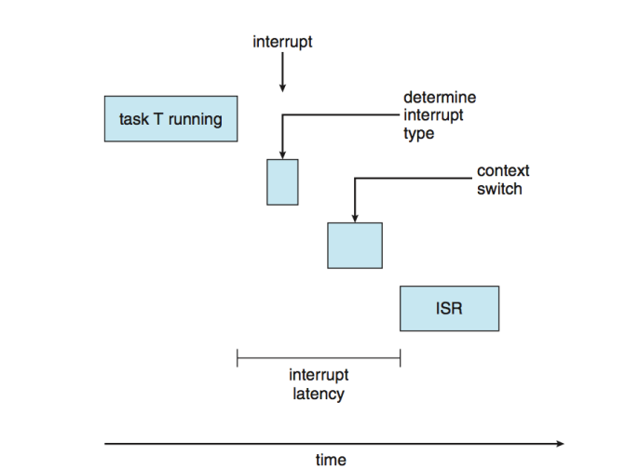 6_14.pdf

* Conflict phase of dispatch latency
  1. Preemption of any process running in kernel mode
  2. Release by low-priority process of resources needed by high-priority processes

**Priority-based Scheduling**

* For real-time scheduling, scheduler must support preemptive, priority-based scheduling
  + But only guarantees soft real-time
* For hard real-time must also provide ability to meet deadlines
* Processes have new characteristics: **periodic** ones require CPU at constant intervals
  + Has processing time *t*, deadline *d,* period *p*
  + 0 ≤ *t* ≤ *d* ≤ *p*
  + **Rate** of periodic task is 1/*p*

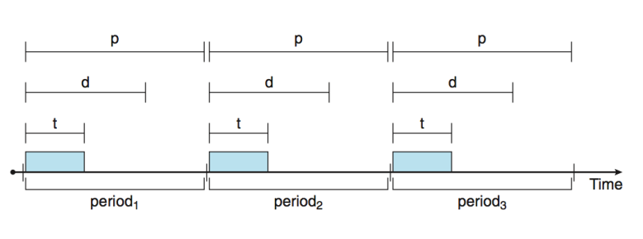

**Rate Montonic Scheduling**

* A priority is assigned based on the inverse of its period
* Shorter periods = higher priority;
* Longer periods = lower priority
* P1 is assigned a higher priority than P2,
  + *p*1=50, *t*1=20, *p*2=100, and *t*2=35

**Earliest Deadline First Scheduling (EDF)**

* Priorities are assigned according to deadlines
  + The earlier the deadline, the higher the priority
  + The later the deadline, the lower the priority

**Proportional Share Scheduling**

* *T* shares are allocated among all processes in the system
* An application receives *N* shares where *N < T*
* This ensures each application will receive ***N*** */ T* of the total processor time

**Linux Scheduling Through Version 2.5**

* *O*(1) scheduling time
  + Preemptive, priority based
  + Two priority ranges: time-sharing and real-time
  + **Real-time** range from 0 to 99 and **nice** value from 100 to 140
  + Map into global priority with numerically lower values indicating higher priority
  + Higher priority gets larger *q*
  + Task run-able as long as time left in time slice (**active**)
  + If no time left (**expired**), not run-able until all other tasks use their slices
  + All run-able tasks tracked in per-CPU **runqueue** data structure
    - Two priority arrays (active, expired)
    - Tasks indexed by priority
    - When no more active, arrays are exchanged
  + Worked well, but poor response times for interactive processes

**Linux Scheduling in Version 2.6.23 +**

* ***Completely Fair Scheduler*** (CFS)
* **Scheduling classes**
  + Each has specific priority
  + Scheduler picks highest priority task in highest scheduling class
  + Rather than quantum based on fixed time allotments, based on proportion of CPU time
  + Two scheduling classes included, others can be added
    1. default
    2. real-time
* Quantum calculated based on **nice value** from -20 to +19
  + Lower value is higher priority
  + Calculates **target latency** – interval of time during which task should run at least once
  + Target latency can increase if say number of active tasks increases
* CFS scheduler maintains per task **virtual run time** in variable **vruntime**
  + Associated with decay factor based on priority of task – lower priority is higher decay rate
  + Normal default priority yields virtual run time = actual run time
* To decide next task to run, scheduler picks task with lowest virtual run time

**Windows Scheduling**

* Windows uses priority-based preemptive scheduling
* Highest-priority thread runs next
* **Dispatcher**is scheduler
* Thread runs until (1) blocks, (2) uses time slice, (3) preempted by higher-priority thread
* Real-time threads can preempt non-real-time
* 32-level priority scheme
* **Variable class** is 1-15, **real-time class** is16-31
* Priority 0 is memory-management thread
* Queue for each priority
* If no run-able thread, runs **idle thread**
* Win32 API identifies several priority classes to which a process can belong
  + REALTIME\_PRIORITY\_CLASS, HIGH\_PRIORITY\_CLASS, ABOVE\_NORMAL\_PRIORITY\_CLASS,NORMAL\_PRIORITY\_CLASS, BELOW\_NORMAL\_PRIORITY\_CLASS, IDLE\_PRIORITY\_CLASS
  + All are variable except REALTIME
* A thread within a given priority class has a relative priority
  + TIME\_CRITICAL, HIGHEST, ABOVE\_NORMAL, NORMAL, BELOW\_NORMAL, LOWEST, IDLE
* Priority class and relative priority combine to give numeric priority
* Base priority is NORMAL within the class
* If quantum expires, priority lowered, but never below base
* If wait occurs, priority boosted depending on what was waited for
* Foreground window given 3x priority boost
* Windows 7 added **user-mode scheduling** (**UMS**)
  + Applications create and manage threads independent of kernel
  + For large number of threads, much more efficient
  + UMS schedulers come from programming language libraries like C++ **Concurrent Runtime** (ConcRT) framework

**Solaris**

* Priority-based scheduling
* Six classes available
  + Time sharing (default) (TS)
  + Interactive (IA)
  + Real time (RT)
  + System (SYS)
  + Fair Share (FSS)
  + Fixed priority (FP)
* Given thread can be in one class at a time
* Each class has its own scheduling algorithm
* Time sharing is multi-level feedback queue
  + Loadable table configurable by sysadmin
* Scheduler converts class-specific priorities into a per-thread global priority
  + Thread with highest priority runs next
  + Runs until (1) blocks, (2) uses time slice, (3) preempted by higher-priority thread
  + Multiple threads at same priority selected via RR

**Algorithm Evaluation**

* **Deterministic modeling**
  + Type of **analytic evaluation**
  + Takes a particular predetermined workload and defines the performance of each algorithm for that workload
* For each algorithm, calculate minimum average waiting time
* Simple and fast, but requires exact numbers for input, **applies only to those inputs**

**Queueing Models**

* Describes the arrival of processes, and CPU and I/O bursts probabilistically
  + Commonly exponential, and described by mean
  + Computes average throughput, utilization, waiting time, etc
* Computer system described as network of servers, each with queue of waiting processes
  + Knowing arrival rates and service rates
  + Computes utilization, average queue length, average wait time, etc

**Little’s Formula**

* *n* = average queue length
* *W* = average waiting time in queue
* *λ* = average arrival rate into queue
* Little’s law – in steady state, processes leaving queue must equal processes arriving, thus  
  *n* = *λ* x *W*
  + Valid for any scheduling algorithm and arrival distribution
* **For example, if on average 7 processes arrive per second, and normally 14 processes in queue, then average wait time per process = 2 seconds**

**Simulations**

* Queuing models limited
* **Simulations** more accurate
  + Programmed model of computer system
  + Clock is a variable
  + Gather statistics indicating algorithm performance
  + Data to drive simulation gathered via
    - Random number generator according to probabilities
    - Distributions defined mathematically or empirically
    - Trace tapes record sequences of real events in real systems

**Implementation**

* Even simulations have limited accuracy
* Just implement new scheduler and test in real systems
  + High cost, high risk
  + Environments vary
* Most flexible schedulers can be modified per-site or per-system
* Or APIs to modify priorities
* But again environments vary

**Chapter 8: Memory-Management Strategies**

* Program must be brought **(from disk) into memory** and placed within a **process** for it to be run
* **Main memory and registers are only storage CPU can access directly**
* Memory unit only sees a stream of **addresses + read requests, or address + data and write requests**
* Register access in **one CPU clock** (or less)
* Main memory can take many cycles, causing a **stall**
* **Cache** sits between main memory and CPU registers
* Protection of memory required to ensure correct operation
* A pair of **base** and **limit** **registers** define the logical address space
* CPU must check every memory access generated in user mode to be sure it is between base and limit for that user CPU检查base和limit register

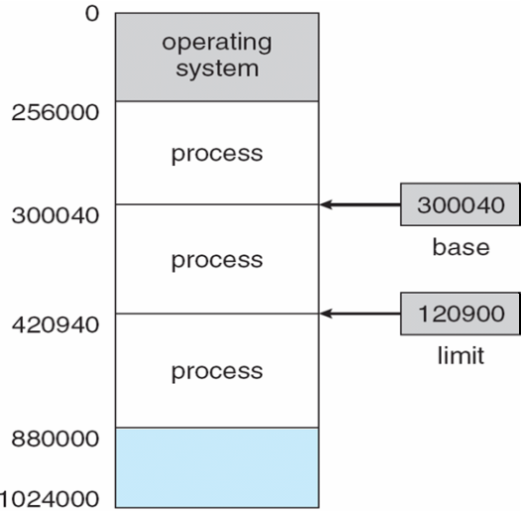

**Address Binding**

* Programs on disk, ready to be brought into memory to execute form an **input queue**
  + Without support, must be loaded into address 0000
* Inconvenient to have first user process physical address always at 0000
  + How can it not be?
* Further, addresses represented in different ways at different stages of a program’s life
  + Source code addresses usually symbolic
  + Compiled code addresses **bind** to relocatable addresses
    - i.e. “14 bytes from beginning of this module”
  + Linker or loader will bind relocatable addresses to absolute addresses
    - i.e. 74014
  + Each binding maps one address space to another

**Binding of Instructions and Data to Memory**

* Address binding of instructions and data to memory addresses can happen at three different stages
  + **Compile time**: If memory location known a priori, **absolute code** can be generated; must recompile code if starting location changes
  + **Load time**: Must generate **relocatable code** if memory location is not known at compile time
  + **Execution time**: Binding delayed until run time if the process can be moved during its execution from one memory segment to another
    - Need hardware support for address maps (e.g., base and limitregisters)

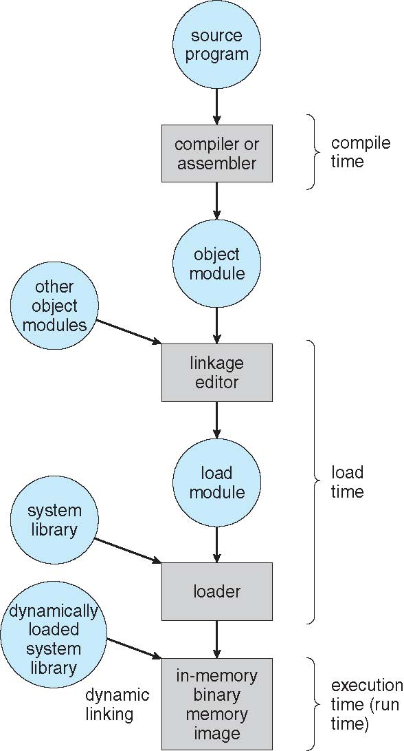 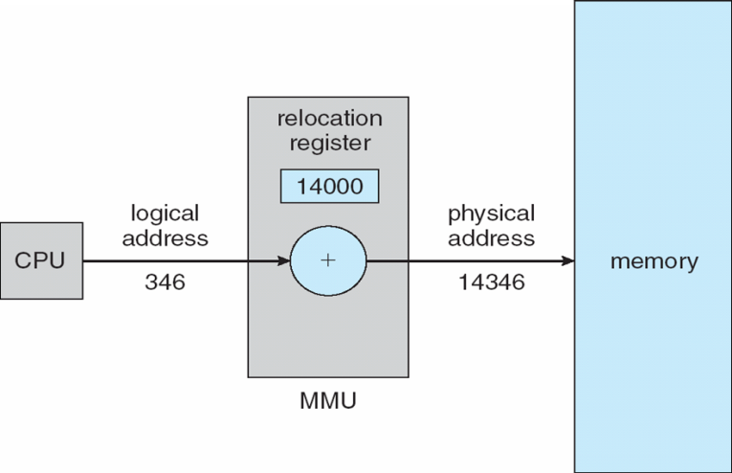

**Logical vs. Physical Address Space**

* The concept of a logical address space that is bound to a separate **physical address space** is central to proper memory management
  + **Logical address** – generated by the CPU; also referred to as **virtual address**
  + **Physical address** – address seen by the memory unit
  + Logical and physical addresses are the same in **compile-time and load-time address-binding schemes**; logical (virtual) and physical addresses differ in **execution-time address-binding scheme 差别在运行时**
* **Logical address space** is the set of all logical addresses generated by a program
* **Physical address space** is the set of all physical addresses generated by a program

逻辑地址 + 虚拟地址

**Memory-Management Unit (MMU)**

* Hardware device that **at run time maps virtual to physical address**
* To start, consider simple scheme where the value in the relocation register is added to every address generated by a user process at the time it is sent to memory
  + Base register now called **relocation register**
* The user program deals with *logical* addresses; it never sees the *real* physical addresses
  + Execution-time binding occurs when reference is made to location in memory
  + Logical address bound to physical addresses

**Dynamic relocation using a relocation register**

* Routine is not loaded until it is called
* Better memory-space utilization; unused routine is never loaded
* All routines kept on disk in relocatable load format
* Useful when large amounts of code are needed to handle infrequently occurring cases
* No special support from the operating system is required
  + Implemented through program design
  + OS can help by providing libraries to implement dynamic loading

**Dynamic Linking**

* **Static linking** – **system libraries and program** code combined by the **loader** into the **binary program image**
* Dynamic linking –linking postponed until **execution time**
* **Small piece of code, stub, used to locate the appropriate memory-resident library routine**
* **Stub replaces itself with the address of the routine, and executes the routine**
* Operating system checks if routine is in processes’ memory address
  + If not in address space, add to address space
* Dynamic linking is particularly useful for libraries
* System also known as **shared libraries**
* Consider applicability to patching system libraries
  + Versioning may be needed

**Swapping**

* A process can be **swapped** temporarily out of memory to a backing store, and then brought back into memory for continued execution
  + Total physical memory space of processes can exceed physical memory
* **Backing store** – fast disk large enough to accommodate copies of all memory images for all users; must provide direct access to these memory images
* **Roll out, roll in** – swapping variant used for priority-based scheduling algorithms; lower-priority process is swapped out so higher-priority process can be loaded and executed
* Major part of swap time is transfer time; total transfer time is directly proportional to the amount of memory swapped
* System maintains a **ready queue** of ready-to-run processes which have memory images on disk
* Does the swapped out process need to swap back in to same physical addresses?
* Depends on address binding method
  + Plus consider pending I/O to / from process memory space
* Modified versions of swapping are found on many systems (i.e., UNIX, Linux, and Windows)
  + Swapping normally disabled
  + Started if more than threshold amount of memory allocated
  + Disabled again once memory demand reduced below threshold

**Schematic View of Swapping**

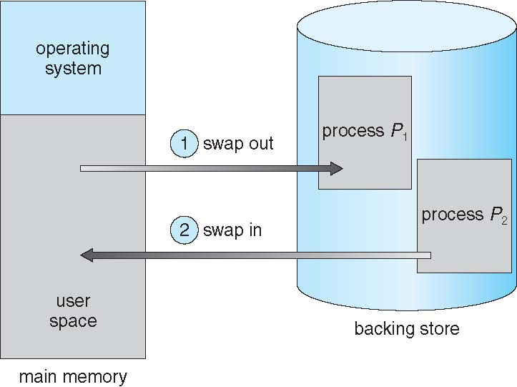

**Context Switch Time including Swapping**

* If next processes to be put on CPU is not in memory, need to swap out a process and swap in target process
* Context switch time can then be very high
* 100MB process swapping to hard disk with transfer rate of 50MB/sec
  + Swap out time of 2000 ms
  + Plus swap in of same sized process
  + Total context switch swapping component time of 4000ms (4 seconds)
* Can reduce if reduce size of memory swapped – by knowing how much memory really being used
  + System calls to inform OS of memory use via request memory() and release memory()
* Other constraints as well on swapping
  + Pending I/O – can’t swap out as I/O would occur to wrong process
  + Or always transfer I/O **to kernel space**, then to I/O device
    - Known as **double buffering**, adds overhead
* Standard swapping not used in modern operating systems
  + But modified version common
    - Swap only when free memory extremely low
    - Use <= 30% of memory

很少用, 交换的开销大

**Swapping on Mobile Systems**

* Not typically supported
  + Flash memory based
    - Small amount of space
    - Limited number of write cycles
    - Poor throughput between flash memory and CPU on mobile platform
* Instead use other methods to free memory
  + iOS ***asks*** apps to voluntarily relinquish allocated memory
    - Read-only data thrown out and reloaded from flash if needed
    - Failure to free can result in termination
  + Android terminates apps if low free memory, but first writes **application state** to flash for fast restart
  + Both OSes support paging as discussed below

**Contiguous Allocation**

* Main memory must support both OS and user processes
* Limited resource, must allocate efficiently
* Contiguous allocation is one early method
* Main memory usually into two **partitions**:
  + Resident operating system, usually held in low memory with interrupt vector
  + User processes then held in high memory
  + Each process contained in single contiguous section of memory
* Relocation registers used to protect user processes from each other, and from changing operating-system code and data
  + Base register contains value of smallest physical address
  + Limit register contains range of logical addresses – each logical address must be less than the limit register
  + MMU maps logical address *dynamically*
  + Can then allow actions such as kernel code being **transient** and kernel changing size

**Hardware Support for Relocation and Limit Registers**

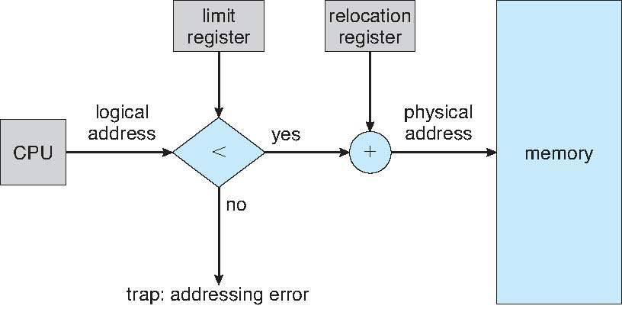

* Multiple-partition allocation
  + Degree of multiprogramming limited by number of partitions
  + **Variable-partition** sizes for efficiency (sized to a given process’ needs)
  + **Hole** – block of available memory; holes of various size are scattered throughout memory
  + When a process arrives, it is allocated memory from a hole large enough to accommodate it
  + Process exiting frees its partition, adjacent free partitions combined
  + Operating system maintains information about:  
    a) allocated partitions b) free partitions (hole)

OS储存的信息: 分配的分区, 自由分区. 处理空区hole

**Dynamic Storage-Allocation Problem**

How to satisfy a request of size ***n*** from a list of free holes?

* **First-fit**: Allocate the ***first*** hole that is big enough
* **Best-fit**: Allocate the ***smallest*** hole that is big enough; **must search entire list**, unless ordered by size
  + Produces the smallest leftover hole

**n Worst-fit**: Allocate the ***largest*** hole; must also search **entire** list

* + Produces the largest leftover hole

First-fit and best-fit better than worst-fit in terms of speed and storage utilization

**Fragmentation**

* **External Fragmentation** – total memory space exists to satisfy a request, but it is not contiguous (no hole larger enough to accommodate incoming process)
* **Internal Fragmentation** – allocated memory may be slightly larger than requested memory; **this size difference** is memory internal to a partition, but not being used 微小碎片
* File size 文件大小 < Allocated memory 占用空间
* First fit analysis reveals that given *N* blocks allocated, 0.5 *N* blocks lost to fragmentation
  + 1/3 may be unusable -> **50-percent rule**
* Reduce external fragmentation by **compaction**
  + Shuffle memory contents to place all free memory together in one large block
  + Compaction is possible *only* if relocation is dynamic, and is done at execution time
  + I/O problem
    - Latch job in memory while it is involved in I/O
    - Do I/O only into OS buffers
* Now consider that backing store has same fragmentation problems

**Segmentation 分段**

* A program is **a collection of segments**

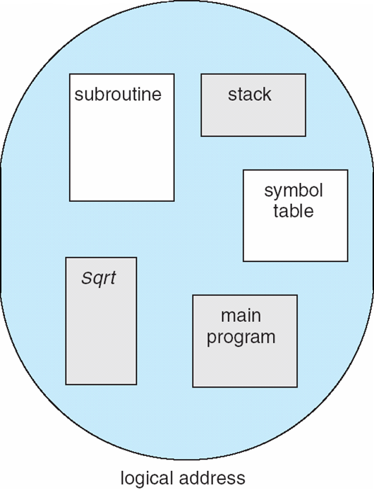 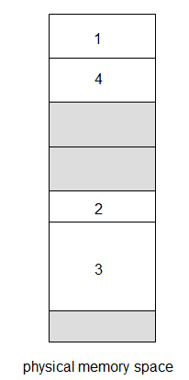

**Segmentation Architecture**

* Logical address consists of a two tuple:

<segment-number, offset>,

* **Segment table** – maps two-dimensional physical addresses; each table entry has
  + **base** – contains the starting physical address where the segments reside in memory
  + **limit** – specifies **the length** of the segment
  + **Segment-table base register (STBR)** points to the segment table’s location in memory
* **Segment-table length register (STLR)** indicates number of segments used by a program;

**segment number *s* is legal if *s* < STLR**

* Protection
  + With each entry in segment table associate:
    - **validation bit = 0** ⇒ **illegal segment**
    - read/write/execute privileges
    - Protection bits associated with segments; code sharing occurs at segment level
* Since segments vary in length, memory allocation is a dynamic storage-allocation problem

**Segmentation Hardware 注意limit (长度) + base (起点) 就行了**

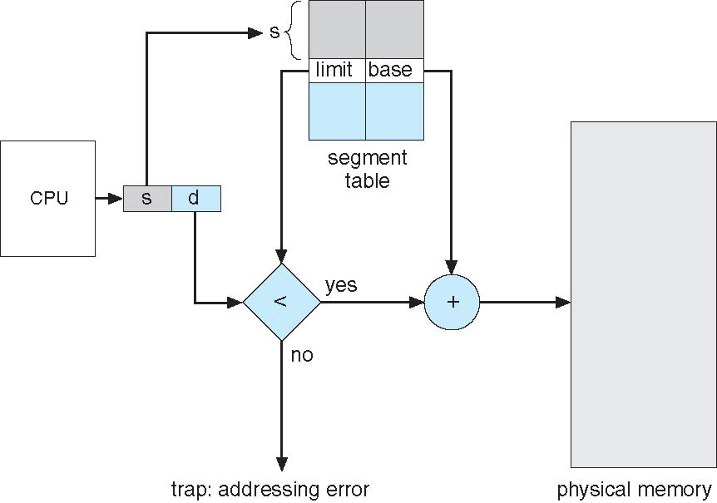

**Paging**

* Physical address space of a process can be noncontiguous; process is allocated physical memory whenever the latter is available
  + **Avoids external fragmentation**
  + Avoids problem of varying sized memory chunks 页：相同size
* Divide **physical memory** into fixed-sized blocks called **frames**
  + Size is power of 2, between 512 bytes and 16 Mbytes （hardware）
* Divide **logical memory** into blocks of same size called **pages**
* Keep track of all **free frames （program）**
* To run a program of size ***N***pages, need to find ***N*** free frames and load program （not necessary）
* Set up a **page table** to translate **logical to physical addresses**
* Backing store likewise split into pages
* Still **have Internal fragmentation**

**Address Translation Scheme**

* Address generated by CPU is divided into:
  + **Page number** (***p***) – used as an index into a **page table** which contains base address of each page in physical memory
  + **Page offset** (***d***) – combined with base address to define the physical memory address that is sent to the memory unit
  + For given logical address space 2*m* and page size*2*n

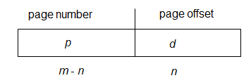

Page table记录frame number 加上 offset 就可以在physical memory里面找了

* Calculating internal fragmentation
  + Page size = 2,048 bytes
  + Process size = 72,766 bytes
  + 35 pages + 1,086 bytes
  + Internal fragmentation of 2,048 - 1,086 = 962 bytes
  + Worst case fragmentation = 1 frame – 1 byte
  + On average fragmentation = 1 / 2 frame size
  + So small frame sizes desirable?
  + But each page table entry takes memory to track
  + Page sizes growing over time
    - Solaris supports two page sizes – 8 KB and 4 MB
* Process view and physical memory now very different
* By implementation process can only access its own memory

**Implementation of Page Table**

* Page table is kept in main memory
* **Page-table base register** (**PTBR**) points to the page table
* **Page-table length register** (**PTLR**) indicates size of the page table
* In this scheme every data/instruction access requires two memory accesses
  + One for the page table and one for the data / instruction
* The two memory access problem can be solved by the use of a special fast-lookup hardware cache called **associative memory** or **translation look-aside buffers** (**TLBs**)
* Some TLBs store **address-space identifiers** (**ASIDs**)in each TLB entry – uniquely identifies each process to **provide address-space protection** for that process
  + Otherwise need to flush at every context switch
* TLBs typically small (64 to 1,024 entries)
* On a TLB miss, value is loaded into the TLB for faster access next time
  + **Replacement policies** must be considered
  + Some entries can be **wired down** for permanent fast access

TLB: 快速缓存.

* Associative memory – parallel search

* Address translation (p, d)
  + If p is in associative register, get frame # out
  + Otherwise get frame # from page table in memory

TLB的结构: page number; frame number

* Associative Lookup = ε time unit
  + Can be **< 10% of memory access time**
  + Hit ratio = α
  + Hit ratio – percentage of times that a page number is found in the associative registers; ratio related to number **of associative registers**
  + Consider α = 80%, ε = 20ns for TLB search, 100ns for memory access
* **Effective Access Time** (**EAT**)

EAT = (1 + ε) α + (2 + ε)(1 – α)

= 2 + ε – α

* Consider α = 80%, ε = 20ns for TLB search, 100ns for memory access
  + **EAT = 0.80 x 120 + 0.20 x 220 = 140ns !!!! ?????**
  + Consider more realistic hit ratio -> α = 99%, ε = 20ns for TLB search, 100ns for memory access
  + EAT = 0.99 x 100 + 0.01 x 200 = 101ns

页表存在内存里.

0.8\*120+0.2\*200???为啥乘一百

**Memory Protection**

* Memory protection implemented by associating protection bit with each frame to indicate if **read-only or read-write** access is allowed
  + Can also add more bits to indicate **page execute-only**, and so on
* **Valid-invalid** bit attached **to each entry** in the page table:
  + “valid” indicates that the associated page is **in** the process’ logical address space, and is thus a **legal page**
  + **“invalid”** indicates that the page is not in the process’ logical address space
  + Or use **page-table length register** (**PTLR**)
  + Any violations result in a trap to the kernel

有效位. valid:在页表里面. invalid:不在噢

**Shared Pages 共享页**

* **Shared code**
  + One copy of read-only (**reentrant**) code shared among processes (i.e., text editors, compilers, window systems)
  + Similar to **multiple threads sharing the same process space**
  + Also useful for interprocess communication if sharing of read-write pages is allowed

**Private code and data**

* + Each process keeps **a separate copy of the code and data**
  + The pages for the private code and data can appear anywhere in the logical address space

**Structure of the Page Table**

很大的page table, 解决方案:

**Hierarchical Page Tables**

* Break up the logical address space into multiple page tables
* A simple technique is a two-level page table
* We then page the page table

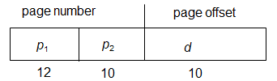

* **forward-mapped page table**

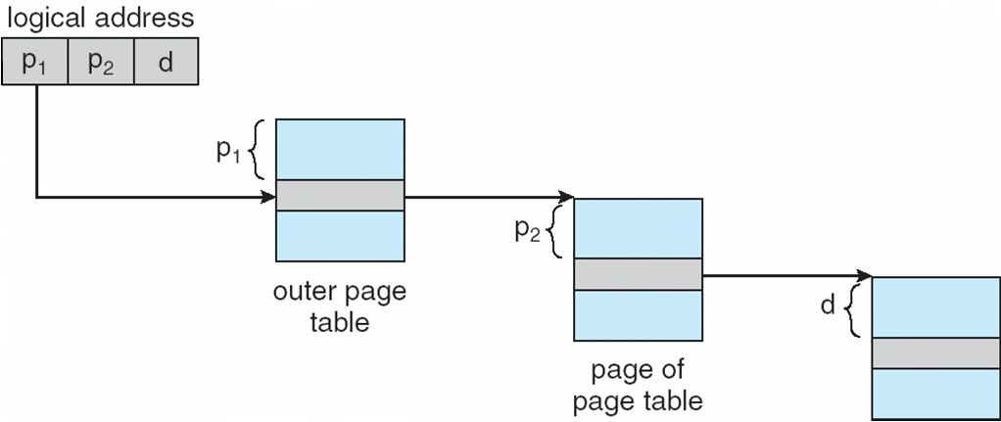

多层页表.

**Hashed Page Tables 哈希页表.**

* Common in address spaces > 32 bits
* The virtual page number is hashed into a page table
  + This page table contains a chain of elements hashing to the same location
  + Each element contains (1) the virtual page number (2) the value of the mapped page frame (3) a pointer to the next element
* Virtual page numbers are compared in this chain searching for a match
  + If a match is found, the corresponding physical frame is extracted
  + Variation for 64-bit addresses is **clustered page tables**
  + Similar to hashed but each entry refers to several pages (such as 16) rather than 1
  + Especially useful for **sparse** address spaces (where memory references are non-contiguous and scattered)

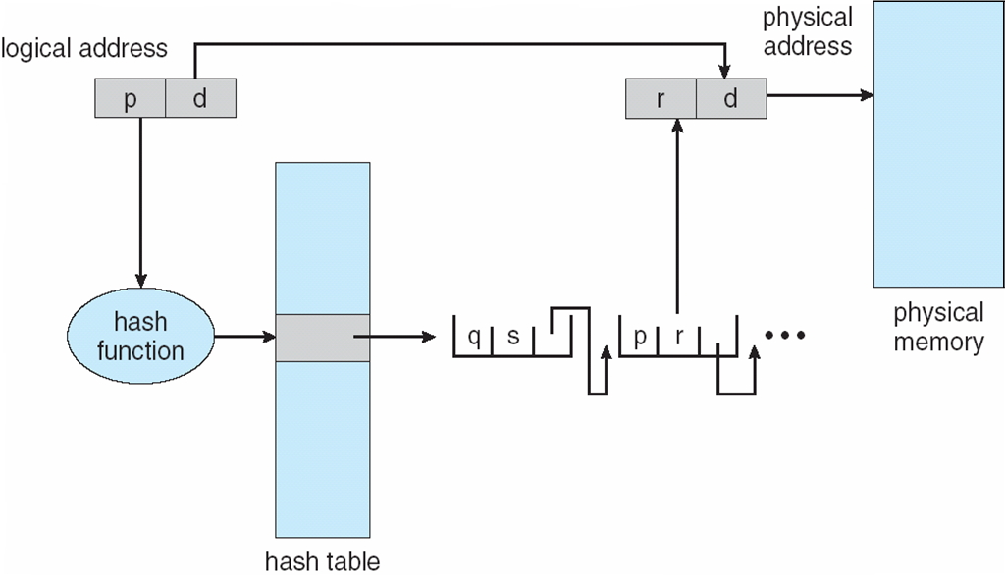

**Inverted Page Table**

* Rather than each process having a page table and keeping track of all possible logical pages, track all physical pages
* One entry for each real page of memory
* Entry consists of the virtual address of the page stored in that real memory location, with information about the process that owns that page
* Decreases memory needed to store each page table, but increases time needed to search the table when a page reference occurs
* Use hash table to limit the search to one — or at most a few — page-table entries
  + TLB can accelerate access
* But how to implement shared memory?
  + One mapping of a virtual address to the shared physical address

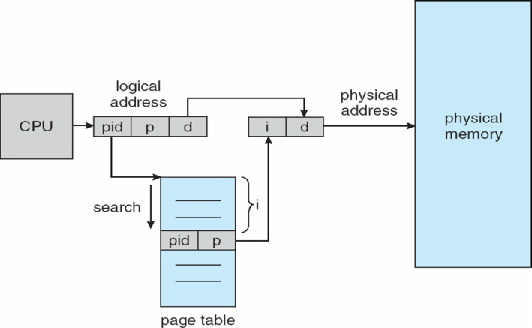

Index代表frame number

**Example: The Intel IA-32 Architecture**

* Supports both segmentation and segmentation with paging
  + Each segment can be 4 GB
  + Up to 16 K segments per process
  + Divided into two partitions
    - First partition of up to 8 K segments are private to process (kept in **local descriptor table** (**LDT**))
    - Second partition of up to 8K segments shared among all processes (kept in **global descriptor table** (**GDT**))
* CPU generates logical address
  + Selector given to segmentation unit
    - Which produces linear addresses
  + Linear address given to paging unit
    - Which generates physical address in main memory
    - Paging units form equivalent of MMU
    - Pages sizes can be 4 KB or 4 MB

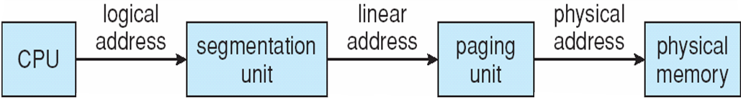

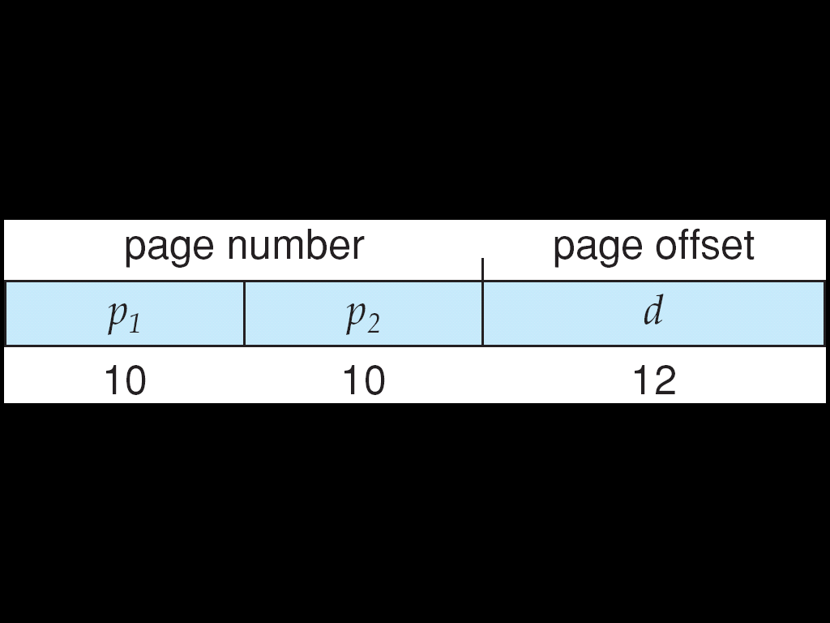

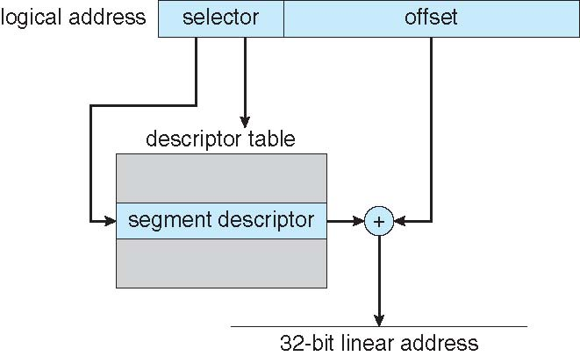

**Intel x86-64**

**Example: ARM Architecture sections**

**Chapter 9: Virtual-Memory Management**

* + Error code, unusual routines, large data structures

**Virtual memory** – separation of user logical memory from physical memory

* + Only part of the program needs to be in memory for execution
  + Logical address space can therefore be much larger than physical address space
  + Allows address spaces to be shared by several processes
  + Allows for more efficient process creation
  + More programs running concurrently
  + Less I/O needed to load or swap processes
* Virtual memory can be implemented via:
  + Demand paging
  + Demand segmentation

虚拟内存＞物理内存

Shared library & page

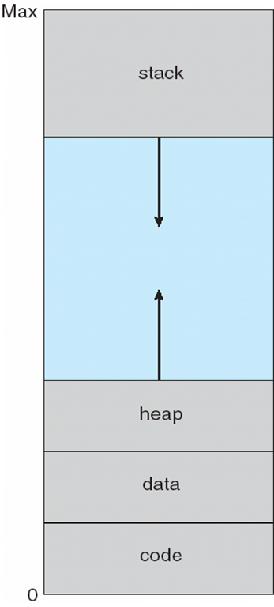

* **Lazy swapper** – never swaps a page into memory unless page will be needed
  + Swapper that deals with pages is a **pager**

With each page table entry a valid–invalid bit is associated   
(**v** ⇒ in-memory – **memory resident**, **i** ⇒ not-in-memory)

* + Invalid reference ⇒ abort
* Operating system looks at another table to decide:
  + Invalid reference ⇒ abort
  + Just not in memory
* Get empty frame
* Swap page into frame via scheduled disk operation
* Reset tables to indicate page now in memory  
  Set validation bit = **v**
* Restart the instruction that caused the page fault
  + **Pure demand paging**
  + **locality of reference**

**swap space**

* **Global replacement** – process selects a replacement frame from the set of all frames; one process can take a frame from another
  + But then process execution time can vary greatly
  + But greater throughput so more common
* **Local replacement** – each process selects from only its own set of allocated frames
  + More consistent per-process performance
  + But possibly underutilized memory

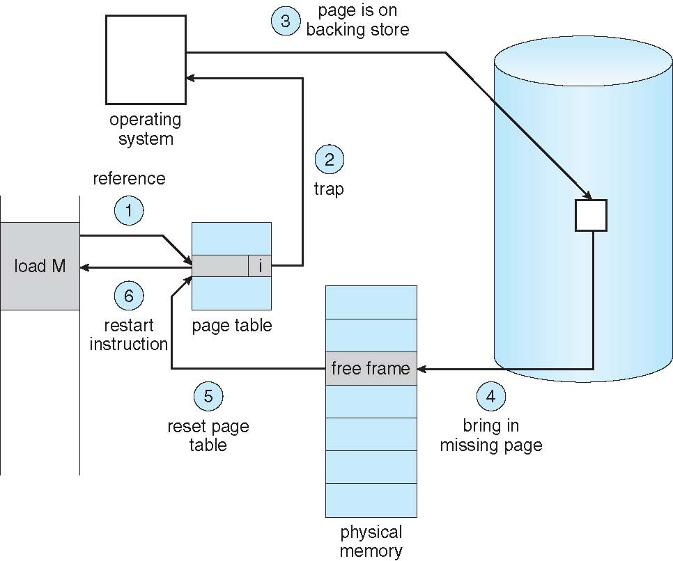

Δ ≡ working-set window ≡ a fixed number of page references

* *WSSi* (working set of Process *Pi*) =  
  total number of pages referenced in the most recent Δ (varies in time)
  + if Δ too small will not encompass entire locality
  + if Δ too large will encompass several localities
  + if Δ = ∞ ⇒ will encompass entire program
* Establish “acceptable” **page-fault frequency** rate and use local replacement policy
  + If actual rate too low, process loses frame
  + If actual rate too high, process gains frame

Slab: 合并

* **Slab** is one or more physically contiguous pages
* **Cache** consists of one or more slabs

Each cache filled with **objects** – instantiations of the data structure

* When cache created, filled with objects marked as **free**
* When structures stored, objects marked as **used**

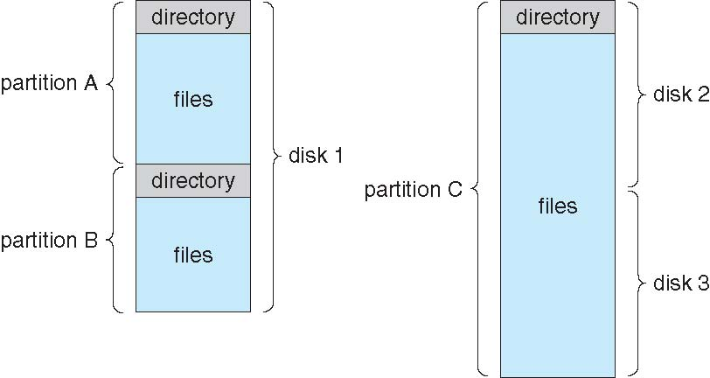

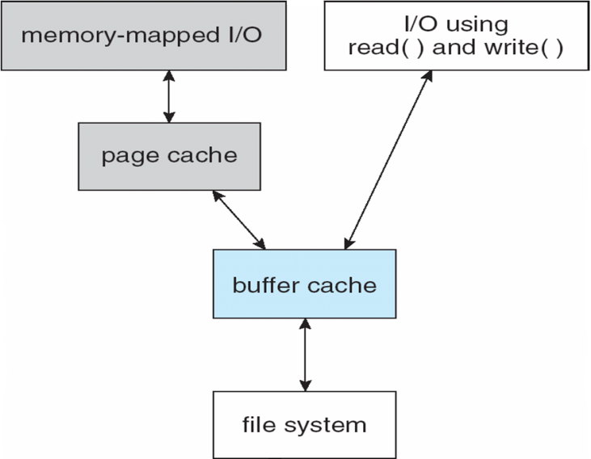 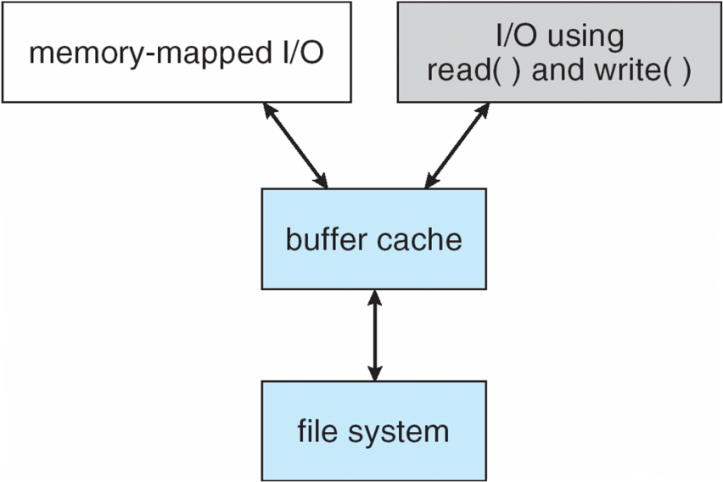

* A **unified buffer cache** uses the same page cache to cache both memory-mapped pages and ordinary file system I/O to avoid **double caching**

总结：

Interrupt中断 硬件/软件发出 停止CPU让其反应 trap/exception overflow /0

What is an operating system?

What is an interrupt? How does operating system handle interrupt?

In what cases will interrupt happen?

What is caching? How is it used?

What is direct memory access?

What are the advantages of multiprocessors systems?

Briefly describe how modern computer works.

What is multiprogramming and multitasking? What’s their difference?

What is a system call. How does OS switch between user mode and kernel mode?

What are the activities of process management?

What are the activities of memory management?

What are the activities of file management?

钟教授上课说过最多的设计原则是什么？

What services do operating system provide?

Why use APIs rather than system calls?

What kinds of system calls do OS provide?

What kind of system programs are there?

What’s the user goals and system goals to design an operating system

What is a microkernel system. Describe its features and draw the diagram of it.

**What is Kernighan’s Law?**

What are the parts of the process? What are their usages?

What is context switch?

What are the zombie and orphans in the process?

What is the producer-consumer problem?

What are the two methods for inter-process communication? Briefly describe them.

What are the blocking and non-blocking send/receive? What are the possible combinations of them?

What are pipes? What are the two kinds of pipes?

What’s the difference between process and thread?

What are the advantages of thread over process?

What is the Amdahl’s Law? (云计算联动)

What are the 3 kinds of thread models? Draw a diagram for each of them. List at least one real-case operating system example for each case.

What is the thread pool? What’s the advantages of it?

What is TLS? What’s the difference between TLS and local variables?

What are the scheduling criteria for process scheduling?

What is the convoy effect?

Which scheduling algorithm gives the shortest average waiting time?

预测题型:Process scheduling 不同算法的次序,平均等待时间计算

What is starvation and its solution in process scheduling?

What are the algorithms used in foreground and background modes?

What’s the difference between soft and hard real-time system?

What is the deterministic modeling in algorithm evaluation?

What’s Little’s Law? If the average wait time per process is 3 seconds and normally 18 processes in queue, what’s the average arrival rate ?

What time can address binding happen?

What are the logical address and physical address? What’s the difference between them?

What is stub in dynamic linking in memory management? What’s its usage?

What is swapping? Briefly describe the mechanism and draw the diagram.

What are the strategies to allocate the memory in contiguous allocation?

What kinds of fragmentation are there? What is 50-percent rule?

What are STBR and STLR in segmentation?

What is TLB? What’s its usage and structure?

What is lazy swapper? (never swaps a page into memory unless page will be needed)

When will an abort happen? (invalid reference)

What are the steps in handling a page fault?

How to solve the instruction restart problem?

* + 1. the microcode computes and attempts to access both ends of both blocks.
    2. The other solution uses temporary registers to hold the values of overwritten locations

How to optimize demand page?

* + 1. Copy entire process image to swap space at process load time
    2. Demand page in from program binary on disk, but discard rather than paging out when freeing frame

What is Copy-on-Write? **Copy-on-Write** (COW) allows both parent and child processes to initially *share* the same pages in memory

What is modify(dirty) bit? What’s its usage?

* **Copy-on-Write** (COW) allows both parent and child processes to initially *share* the same pages in memory

What’s the stage of page replacement?

想要的page—free frame—换，更新页表/框架表

What is Belady’s Anomaly? 增加frame数目造成更多的page fault

What are the algorithms for page replacement? FIFO, LRU, Page buffering (free frames)

What are the counting algorithms?

**LFU Algorithm**: replaces page with smallest count

**MFU Algorithm**: based on the argument that the page with the smallest count was probably just brought in and has yet to be used

What are the allocation schemes? Fixed固定分配，留一些自由池, priority优先级

What are the difference between global and local allocation?

What is thrashing? Why does thrashing occur? **Thrashing** ≡ a process is busy swapping pages in and out Σ size of locality > total memory size

Why does demand paging work? **Locality model**

What are **memory-mapped files**? Memory-mapped file I/O allows file I/O to be treated as routine memory access by **mapping** a disk block to a page in memory

What is buddy system? Allocates memory from fixed-size segment consisting of physically-contiguous pages

* Advantage – quickly coalesce unused chunks into larger chunk
* Disadvantage - fragmentation

What is TLB reach? TLB Reach - The amount of memory accessible from the TLB

What is I/O Interlock? **I/O Interlock** – Pages must sometimes be locked into memory

What is volume in file system? Entity containing file system known as a **volume**

What are the two problems in organizing the directory? Naming and Grouping

How to solve the dangling pointer problem in acyclic-graph directories? Backpointers. Entry-hold-count-solution.

What is a link? Another name (pointer) to an existing file

How to guarantee no cycles in a general graph directories?

Allow only links to file not subdirectories + **Garbage collection** + Every time a new link is added use a cycle detection algorithm to determine whether it is OK

What is NFS? Is it a client-server file sharing protocol? Network File System (NFS), Yes

What does Unix file system (UFS) implement?

* + - Writes to an open file visible immediately to other users of the same open file
    - Sharing file pointer to allow multiple users to read and write concurrently

\*What are the types of access in file system. **Read Write Execute Append Delete** **List**

What does a layered file system include?

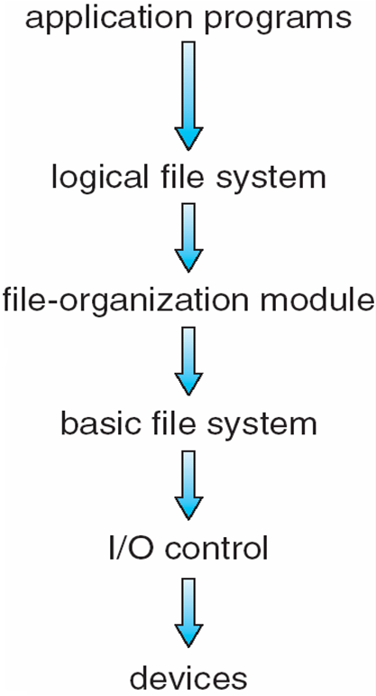

* **Device drivers** manage I/O devices at the I/O control layer
* **Basic file system** given command like “retrieve block 123” translates to device driver
* **File organization module** understands files, logical address, and physical blocks
  + **Logical file system** manages metadata information

What are the advantages and disadvantages of using file system layers?

* + Layering useful for reducing complexity and redundancy, but adds overhead and can decrease performance

What are the boot control block, volume control block and file control block?

* **Boot control block** contains info needed by system to boot OS from that volume
* **Volume control block (superblock, master file table)** contains volume details
* Per-file **File Control Block (FCB)** contains many details about the file （Inode number, permissions, size, dates）

Which partition contains OS? Root partition

When will file system consistency be checked> At mount time.

Describe the structure of VFS.

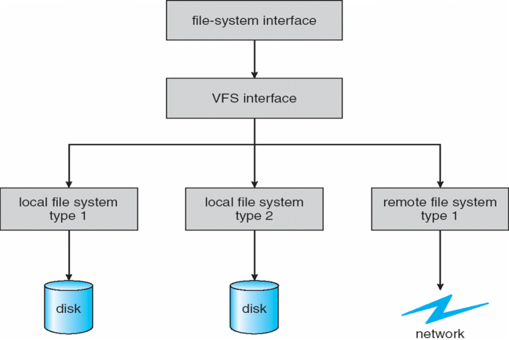

Which allocation method has the best performance in most cases? What information needs to be stored? Contiguous allocation. Start and length

What is an extent? An **extent** is a contiguous block of disks

Draw the logical view of index table for indexed allocation.

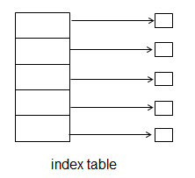

What’s the difference between the I/O using or not using unified buffer cache? Whether there is a page cache

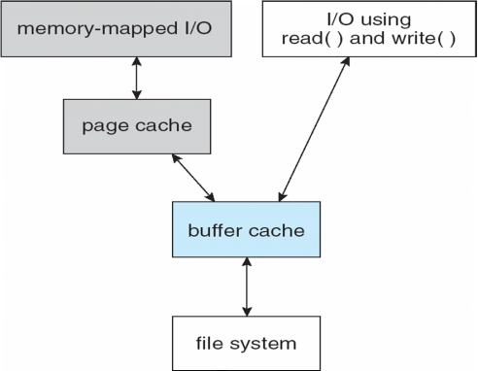 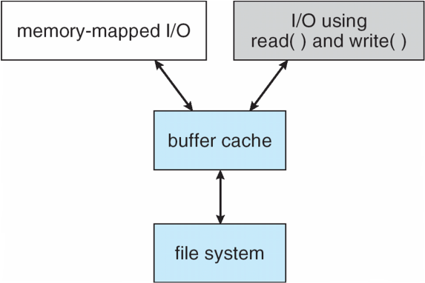

What operations does the NFS procedures support?

* + searching for a file within a directory
  + reading a set of directory entries
  + manipulating links and directories
  + accessing file attributes
  + reading and writing files

What is NFS architecture?

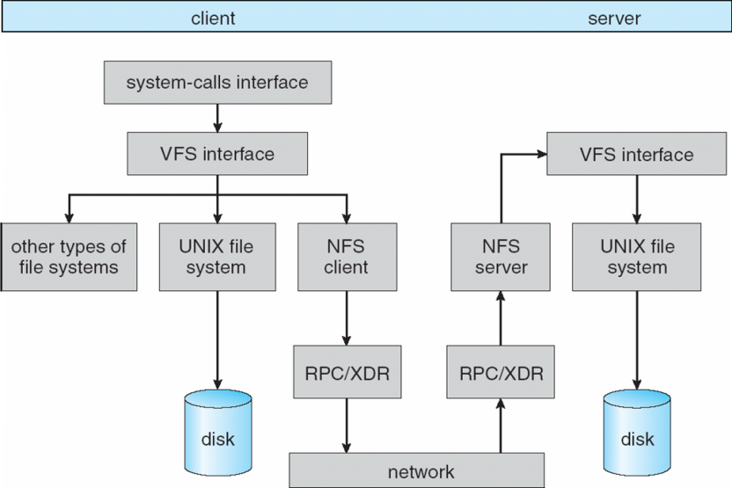

What is an interrupt-driven I/O cycle?

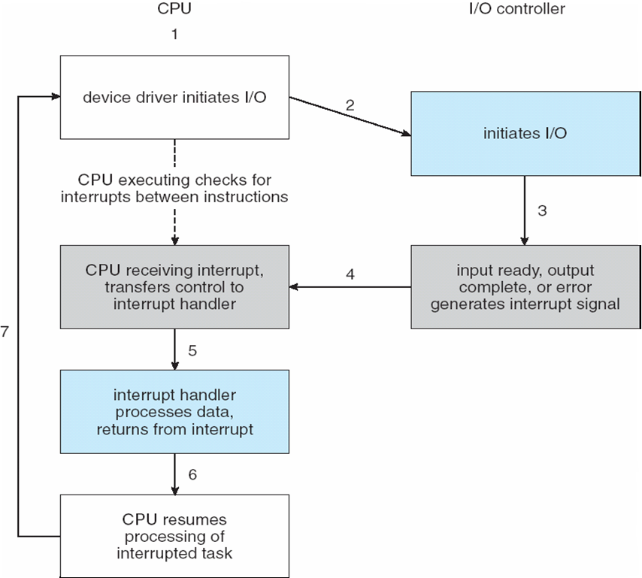

What are the 6 steps to perform DMA transfer?

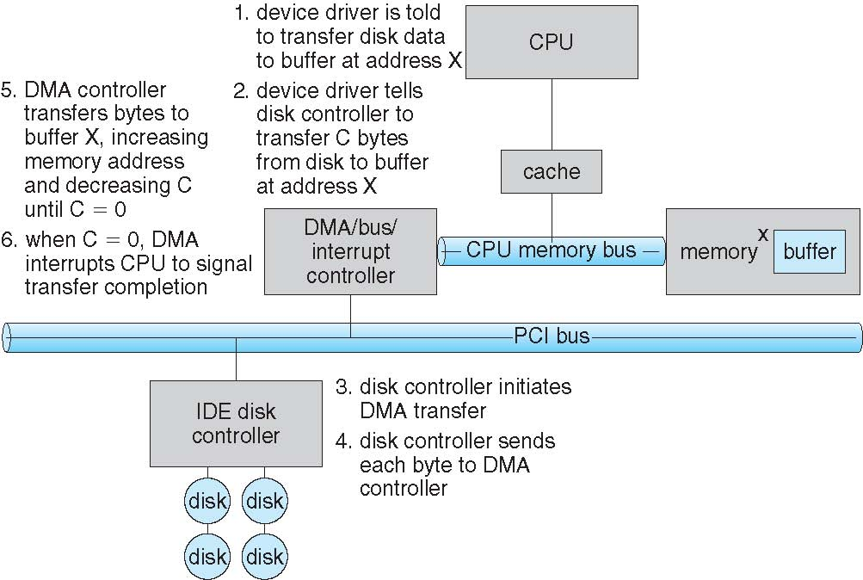

What is the difference between blocking and nonblocking I/O?

* **Blocking** - **process suspended until I/O completed**
* **Nonblocking** - **I/O call returns as much as available**

What is the structure of the stream?

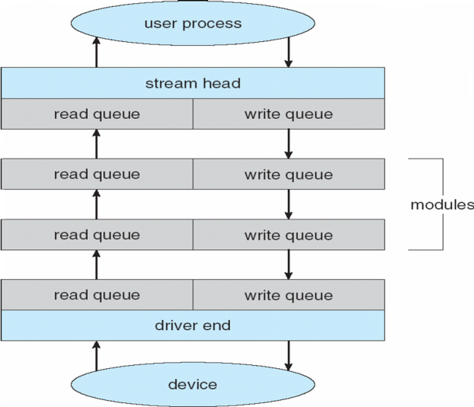

**自己总结！！！**

概念题